

**Sentiment Analysis on Covid-19 Tweets and Forecasting of Vaccination Levels with Focus on Ireland**

by

Gavin Davis

Supervisor: Dr Catherine Mulwa

Presented to CCT college Dublin in fulfilment of the degree Master in Science in Data Analytics

Submitted: September 2023

**Abstract**

**1.Introduction**

**1.1 Topic Area and Motivation**

Data analytics can assist greatly in understanding trends, temporal change and opinion of many different areas of interest. The Covid19 pandemic was something which affected all the world for nearly 3 years. Specific areas of data analytics played a pivotal role in collecting and analysing relevant information to assist and combat the pandemic in an effort to alleviate the damage. A huge amount of data was collected during the pandemic on covid cases, mortality, vaccine uptake, vaccine sentiment and more. Now post pandemic peak we have access to massive datasets related to the pandemic. One problem area during the pandemic was vaccine uptake and hesitancy. Vaccines are administered to help reduce the severity and the spread of infection. Thus vaccination is very beneficial to quell the spread of infection and alleviate the pressure of the pandemic. This project aims to apply data analytical tools such as sentiment analysis and forecasting approaches to understand and predict trends in vaccination sentiment and uptake. Tweet data will be used to generate a predictive vaccine sentiment model with several models being implemented to achieve a model with the highest accuracy. Vaccine uptake will be analysed in Ireland using publicly available datasets from data.gov by using forecasting approaches such as time series analysis. The main focus of this project is sentiment analysis and forecasting approaches as applied to covid19 vaccine data, with the aim of generating useful predictive models for prediction of pandemic related vaccine metrics. The project will focus on understanding sentiment around vaccines by carrying out primary research in the form of a Vaccine awareness survey. The sentiment will be correlated with other factors collected during the primary research phase. A comparative analysis of the sentiment collected from the primary research and the sentiment from the tweet data will be used to understand Irelands position versus the rest of the world.

This project focuses on key methods of data analytics as applied to covid19 data, with primary research carried out to understand vaccine sentiment in Ireland and potential contributing factors:

1. Sentiment analysis applied to covid19 tweet data
2. Time series analysis applied to covid vaccine uptake levels to generate a machine learning models which can predict vaccinations effectively

Each aspect of the project will be addressed as outlined in the research objectives 1-3 below.

**1.2 Research Question and Objectives**

**Justification and Relevance of Project**

The relevance and applicability of this research project will be an understanding of data analytical techniques which can be applied to Covid-19 vaccine data in order to drive decision and policy making for any future relapse or alternative pandemics. The project will use sentiment analysis and primary research to understand the current state of opinion and sentiment towards vaccines in the hope that any models and insight generated can be effectively harnessed to make decisions regarding health measures by science/health sector professionals. The application of forecasting approaches such as time series forecasting to highlight models with accurate predictive power for Covid-19 vaccine levels will showcase which models are best for future use in the prediction of such metrics. The most likely stakeholders with weighted interest in the outcome of this project would be the healthcare industry, and the benefit these models could bring to the sector. On a broader scale the pandemic effected all the world, thus developing new and improved methods for predicting future trends to insight proper planning will be of great benefit to the general population.

**Research Question:**

*Can machine and deep learning techniques be applied for the prediction of covid 19 vaccine data for the benefit policy and decision making in the health sector?*

***Sub-Research Question 1****: What extent can machine and deep learning techniques be exploited to predict Covid-19 vaccine tweet sentiment?*

***Sub-Research Question 2:*** *How does global Covid-19 vaccine tweet sentiment compare to Irelands Covid-19 vaccine sentiment as indicated by a vaccine awareness survey?*

***Sub-Research Question 3****: What extent can machine and deep learning techniques be harnessed to predict Covid-19 vaccine levels in Ireland*

**Research objective 1**

**The aim of this research objective was to investigate vaccine sentiment on Covid-19 tweet data harnessing sentiment analysis techniques, and to apply machine and deep learning models to the data to achieve a model with the highest accuracy.**

The first research objective of this project was to investigate and evaluate the current state of vaccine sentiment post pandemic using sentiment analysis on vaccine related tweets. Tweets were collected using the Twitter API before using natural language processing techniques to prepare and clean text data for polarity measurements using methods such as Textblob and VADER. Tweets collected were processed into a new dataset. The likely outcome will be N understanding of the current state of opinion on vaccines. The sentiment data was used to train multiple machine learning and deep learning models to predict sentiment of new text data. Model accuracy metrics were evaluated and compared to find the best model for sentiment classification with the new tweet dataset. The sentiment data collected from the new tweets dataset was then compared with sentiment data collected from the primary research carried out in research objective 2. As a part of this research objective a comprehensive literature review was written on the state-of-the-art in natural language processing and sentiment analysis, as well as its application to vaccine sentiment related to Covid-19.

**Deliverables:**

* New tweet dataset about covid 19 vaccines
* Understanding of current sentiment around Covid-19 vaccines
* Comparison of best models to use in prediction of sentiment data
* Accurate final model with the highest accuracy
* Comprehensive literature review of sentiment mining techniques, and sentiment analysis as applied to Covid-19 tweet data

**Research objective 2**

**The aim of this research objective was to use a survey as a primary research method to investigate the current sentiment in Ireland around Covid-19 vaccines and perform a comparative analysis with the global tweet sentiment from RO1.**

This part of the research was addressed by creating a short survey to gather responses such as whether people feel positive, negative or neutral towards vaccines. Other repsonses were also gather such as employment category they fall into, and whether they would be likely to receive a vaccine if another pandemic were to occur. The main information of interest was gathered in the final section which is whether people feel positive, neutral or negative towards vaccines. This data was correlated with other metrics collected in the survey such as employment background. Many factors were highlighted as contributing to covid 19 vaccine hesitancy and thus this survey provided an opportunity to correlate sentiment with other data collected such as employment. The two main subgroups in question were people from a science/health background and non-science/health background. The sentiment was also compared against the sentiment analysis performed in RO1. The data generated from this surrvey was analysed and presented in a non-bias manner to understand whether there are differences in vaccine hesitancy and awareness between different employment subgroups as mentioned above .The outcome of this research objective was a new understanding of whether employment in health/science sectors contributes to vaccine sentiment and awareness. Given vaccine hesitancy and the factors which contribute to it were an intense area of investigation during the pandemic, relevant literature was collected and presented in the literature review on the factors which contribute to vaccine uptake and hesitancy.

**Deliverables:**

* New dataset on vaccine sentiment in Ireland related to covid 19
* Understanding of the contribution of employment background, if any, to vaccine sentiment
* Comparison of sentiment analysis on covid 19 vaccine related tweets with sentiment in Ireland generated from primary research survey

**Research objective 3**

**The aim of this research objective was to investigate whether forecasting approaches such as time series models can be applied to Covid-19 vaccine data to generate accurate forecasting models.**

To carry out this aspect of the research project a dataset from data.gov on vaccination levels from Ireland was used. The dataset acquired from gov.ie was explored using exploratory data analysis (EDA) and cleaned for implementation into forecasting models. Visualisations were used to interpret the data and the accuracy of any resulting models. Different time series forecasting models were applied to the data and compared in order to achieve the most accurate model, while comparing accuracy metrics of each respective model. The outcome of this part of the research was the generation an accurate predictive model which could assist the understanding and prediction of vaccine levels in Ireland during the pandemic over time. The literature review carried out as a part of RO1 covered the theory and state-of-the-art behind forecasting approaches with emphasis on time series forecasting and the models which have been applied to Covid-19 data.

**Deliverables:**

* Accurate forecasting model for the prediction of vaccine trends in Ireland
* Comparison of forecasting models as applied to covid 19 data in Ireland
* Comprehensive literature review of forecasting models used in covid 19

**2.Literature review**

**2.1 Background to problem area**

The Covid19 pandemic affected the entire world, bringing economies, trade, employment, education, and health a ream of issues that have not been experienced before. To date, at the time of writing this, 683, 644, 472 coronavirus cases have been recorded with a mortality of 6, 829, 253, approximately 1%. The Covid-19 pandemic is on-going but has reached levels in most countries where some level of normalcy has returned. For many, it was the focus of daily life for 2 years, constantly exposed to case levels, mortality and the situation in other countries on every media outlet available. Given a pandemic of this magnitude has never occurred before, and the ability to gather and process data is more efficient than ever, the pandemic shone a light on data analytics, and its ability to digest, and purpose data to predict the spread, levels of vaccine uptake, sentiment and future waves of the virus (refs). Although infectious diseases such as SARs, H1N1, Ebola and Zhika viruses have threatened this level before, with a prospective worse outcome given their increased severity compared to Covid-19, nothing of this magnitude has been seen or recorded before. Thus Covid-19 is now the model pandemic which will assist the domain of data analytics in generating valuable insights and predictive models to understand the worlds response, failings, areas of concern, vaccine uptake, levels of infrastructure required to combat such levels of widespread infection, to name a few. Hence, the focus of this piece will be how data analytics is being used to study Covid-19 and generate valuable insights and tools to combat the ongoing but subdued pandemic that brought the world to a standstill, highlighting areas relevant to this project. Key areas within the domain of data analytics which this review will focus on are natural language processing, specifically sentiment analysis, and forecasting approaches such as time series forecasting as applied to Covid-19 data and related data.

Healthcare is slowly but surely making the transition to data driven decisions for nearly every facet of the sector, whether it be for patient diagnostics, drug/small molecule discovery, disease severity and onset and drug efficacy (Cascini *et al.*, 2021; Chauhan *et al.*, 2021; Savage, 2021). The Covid-19 pandemic brought to light the power of data analytics and its invaluable contribution to decision and policy making. Data analytics was pivotal in the response and eventual subduing of the covid19 pandemic. A number of tools were used in assisting with the collection, processing, understanding, translation and dissemination of how the pandemic was unfolding, through assessing parameters such as case numbers, severity, vaccine uptake and sentiment. Now with the height of the pandemic seemingly behind us, data generated during the pandemic can be a harnessed to generate deep insights and predictive models that may assist in the future. In line with the aims of this project, sentiment analysis and forecasting approaches will be harnessed, applied and explored using Covid-19 data metrics, and thus this review will focus on the state of the art in these techniques, and their application to covid 19.

**2.2 Natural language processing**

Natural language processing (NLP) is a sub field of AI and linguistics, stemming from the 1950s, which offers a way for a computer to interpret natural languages (Khurana *et al.*, 2023). Given the idiosyncratic nature of languages such as English and common phrases, NLP offers a way in which to vectorise words and phrases making it digestible for algorithms, such as machine and deep learning models. Before delving into the advanced applications of sentiment analysis, it is important to first understand the fundamentals on which it operates, which is NLP. As described in the quote below from Dipanjan Sarkar’s book on text analytics from 2016, natural language follows rules and syntax which can be exploited through commonalities and converted into data which can be analysed mathematically (Sarkar, 2016).

“Textual data is unstructured data but it usually belongs to a specific language following specific syntax and semantics. Any piece of text data—a simple word, sentence, or document—relates back to some natural language most of the time” -Dipanjan Sarkar, 2016

There are several applications for natural language processing including predictive text, email filtering, document analysis, social media monitoring, chatbots, language translation and sentiment analysis (*Applications of Natural Language Processing  | Data Science Dojo*, 2023). More recently, a massive leap forward was made in using predictive text and NLP for the creation of large language models such as Chat GPT-4 by Open AI. This technology harnesses several key processes of natural language processing to allow the user to input information and receive relatively accurate output for various queries or prompts. Natural language processing was applied extensively during the Covid-19 pandemic to assist in digesting massive amounts of text data from sources such as social media, electronic health records, scientific investigation literature and health agency guidelines (Al-Garadi, Yang and Sarker, 2022). The various applications of NLP in covid 19 are shown in Figure 3.1.

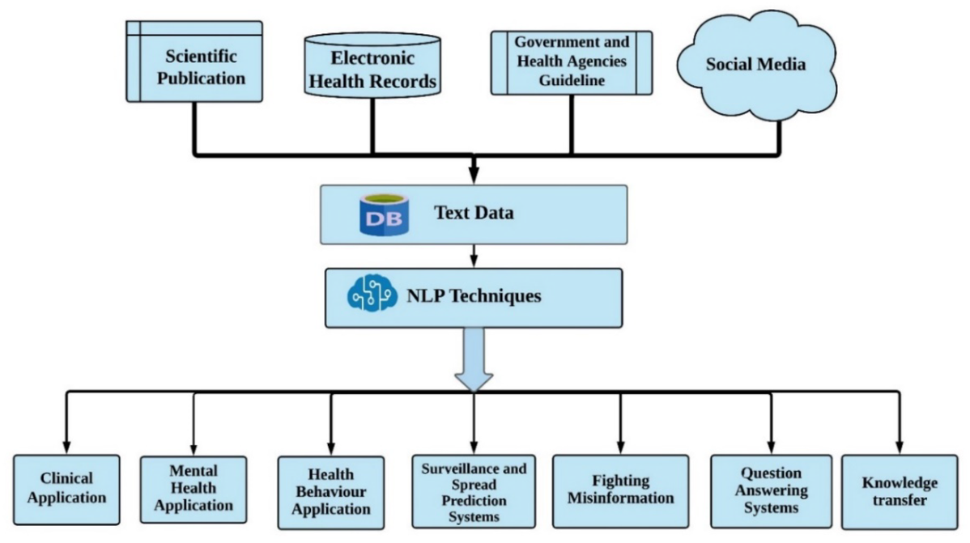

Figure 3.1: Showing summary of NLP methods applied during covid 19 (Al-Garadi, Yang and Sarker, 2022)

A key area which is often used in NLP is sentiment analysis (Gonçalves *et al.*, 2013). Several excellent machine learning and deep learning approaches have been used to develop pre trained models to carry out NLP tasks such sentiment analysis like word2vec, GloVe, BERT (Koroteev, 2021). TextBlob and VADAR, are lexicon based NLP methods, non- machine learning model based methods, rely on a large dictionary of words which the algorithms already possess, and which the training data provided is compared against to perform sentiment tasks (Fang and Zhan, 2015; Kolchyna *et al.*, 2015; Rodríguez-Ibánez *et al.*, 2023). Given a key aim of this project is to mine sentiment from a new twitter dataset generated with the twitter API based on current Covid-19 vaccination tweets, these techniques will be explored and refined for their potential to generate the most accurate model possible for classification of sentiment of the problem area dataset.

**2.3 Sentiment analysis**

Sentiment analysis is a key area of NLP which enables the mining of opinion and feelings around a certain topic. This enables more efficient decision making when it comes to policy and business decisions. Sentiment analysis was applied extensively during the pandemic to mine public opinion particularly in relation to vaccines, this will be discussed in a later section. Simply put, sentiment analysis relies on the ability to process textual data to its rudiments and convert the text data in to numeric type data which can be digested and quantified by various algorithms, such as the ones mentioned in Section 3.2 (Gonçalves *et al.*, 2013). Sentiment analysis is an area of NLP which can determine the positivity, negativity and neutrality of textual data to understand the overriding feeling and opinion on a certain topic (*A Comprehensive Overview of Sentiment Analysis*, 2022). The areas which sentiment analysis can be applied to are endless, including but not limited to, consumer reviews, product reviews, brand reviews and public opinion on social media websites like Twitter and Facebook (Gonçalves *et al.*, 2013; Fang and Zhan, 2015; Cepeda and Jaiswal, 2022; Rodríguez-Ibánez *et al.*, 2023).

The pipeline for performing sentiment analysis involves a number of key NLP tasks and is generally similar across different methods, with a few alterations depending on the model being applied. A critical step common to most sentiment analysis approaches is the cleaning and preparation of the data. A typical pipeline for cleaning and preparing data for sentiment analysis is shown below:

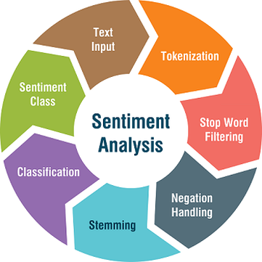

Figure 3.2: Steps cleaning and processing text data for sentiment analysis (*A Sentiment Analysis Approach to Predicting Stock Returns | by Tom Yuz | Medium*, 2023)

The processes required to clean and prepare text data for sentiment analysis are enabled by a number of python libraries, the most prominent of which being Natural language processing toolkit, abbreviated as NLTK (Wang and Hu, 2021). Sentiment analysis involves processing text data by removing noise from the data which takes the form of single characters, punctuation, unnecessary spaces and stop words, such as ‘and’ which don’t add much value in terms of identification to a body of text, thus they are removed in the initial phases of text data cleaning. Another technique used is stemming which reduces similar words to a common rudiment in order to group them together for comparative purposes again reducing the noise, taking the words playing, play and playful, and combining them into a single representative word of play (*Stemming and lemmatization*, 2023). Regular expressions are employed which are common sequences of characters found in natural language which can again remove noise, removing special characters like hashtags or converting all letters to lower case for comparative purposes (*Regular Expressions — An excellent tool for text analysis or NLP | by Niwratti Kasture | Analytics Vidhya | Medium*, 2019). Following this Tokenization, the process of splitting a body of text into individual components is performed, followed by vectorising the words or phrases so they may be used in machine learning algorithms (*Tokenization in NLP: Types, Challenges, Examples, Tools*, 2023). Finally, and most importantly, tools such as TextBlob and VADER, python libraries can be used to gauge the polarity, or machine learning models such as BERT, which provide a rating between -1 and 1, describing the relative positivity, neutrality or negativity of the text. This rating can be highly useful when it comes to mining opinion around a certain topic as, for instance, the number of positive, negative and neutral tweets can be assessed around vaccinations to understand public opinion on the topic (*TextBlob | Making Natural Language Processing easy with TextBlob*, 2022).

As previously mentioned, there are two methods used for sentiment analysis: Lexicon-based and machine learning based. Lexicon-based uses a dictionary of words that are compared against the text being analysed enabling the assignment of polarity measurements associated with positive, negative or neutral words (Kolchyna *et al.*, 2015). This method which is used by TextBlob and VADER, is commonly used. The second method is machine learning based, with examples being methods such as BERT. BERT uses a multi-layer bidirectional transformer encoder which represents the input text in high dimensional space, enabling understanding of the entire context of each word in a collection of text such as a tweet (*Text Classification with BERT. In this tutorial, we will use BERT to… | by Khang Pham | Medium*, 2023) When the model is trained, new text can be given to the model and the model can make predictions based on its training. Many pre-trained models exist for machine learning based approaches such as BERT. The two techniques can be used together, and often are, whereby text data is assigned a sentiment using Lexicon-based approaches and then a BERT model is trained with this data to enable predictions of new data. Aside from advanced techniques such as BERT, sentiment classification models can be trained by combining lexicon or pre-trained machine learning models to classify sentiment of cleaned text data, followed by training of classification or deep learning models with the aim of generating a model which can predict sentiment of new data. Within this project it is the aim to do this using Covid-19 vaccine related tweets, to generate a predictive machine learning model which could be used to assign sentiment to new data of the same topic.

Many different machine learning models have been applied to perform sentiment analysis. Given that sentiment is a classification task for understanding the relative positivity or negativity of textual data many classification models such as Random Forest Classifier (RF Classifier) (Iwendi *et al.*, 2020), Decision Tree Classifier (DTClassifier) (Chinnasamy *et al.*, 2022), Support Vector Machine (SVM) (Binti, Nasir and Palanichamy, 2022), Naïve Bayes Classifier (NBClassifier) (Iksan *et al.*, 2021), XGboost Classifier (XGBClassifier) (Huang and Wang, 2023) and more recently ExtraTrees Classifer (Rustam *et al.*, 2021). As well as these machine learning models, deep learning techniques have been applied to sentiment analysis such as the popular Recurrent neural network (RNN) model known as Long short term memory or LSTM and the relatively new BERT model (Mansoor *et al.*, 2020; Koroteev, 2021). These models have shown excellent accuracies for classifying sentiment in the literature, and importantly for this project, have been applied to mine sentiment for Covid-19 related text data. As well as this, combinations of sentiment mining techniques, vectorization techniques and different machine learning models have been applied to achieve optimal accuracy metrics (Qorib *et al.*, 2023)

**2.4 Sentiment analysis and Covid-19**

Gaining an insight into public sentiment surrounding the pandemic and vaccines was imperative to gain insights and understand how vaccines would be taken up by the general population. Several interesting studies have arisen from sentiment analyses performed on social media, news and more in relation to the Covid-19 pandemic, related to vaccinations in particular. Vaccinations were a topic of constant discussion throughout the course of the pandemic, dividing opinion amongst the general population.

In one particularly interesting study, the sentiment of Covid-19 was compared between twitter and reddit, two popular social media outlets (Melton *et al.*, 2022). In this study, 9.5 million tweets and 70 thousand reddit comments were compared between January 1st 2020 and March 1st 2022. Both platforms shared similar sentiments with Twitter being more negative (54.8% positive) than reddit (62.3% positive), with the sentiments of both platforms displaying similar behaviour related to vaccines during the pandemic (Melton *et al.*, 2022). Another such study analysed sentiment of Covid19 news headlines during the pandemic, harnessing the data for the generation of a highly accurate neural network model (accuracy=0.931) providing an indication of how news outlets such as CNN covered the pandemic and vaccination (Ahmad *et al.*, 2022). Overall these two studies highlight two sentiment analysis was a critical element of DA which contributed to understanding of how the pandemic was unfolding.

A number of models have been applied to mine Covid-19 vaccine sentiment and related topics. For sentiment analysis, it is common practice to apply classification models such as Naïve bayes Classifier. A study in 2021 by Iksan *et al.* mined sentiment from a public tweet dataset based on Covid-19. Their experimental results showed the model accuracy was 0.86 or 86%, with a precision of 0.827, recall of 0.687, and an F-score of 0.749 (Iksan *et al.*, 2021). Another study by Ressan *et al.* in 2022 used multinomial Naïve Bayes Classifier on a Covid-19 tweet dataset consisting of 10,000 tweets. Their model achieved an high accuracy of 91.6% which highlights the power of the Multinomial Naïve Bayes Classifier in sentiment classification tasks. The authors cite that enhanced model accuracy could be reached with a larger dataset (Ressan and Hassan, 2022). Taken together these results show promise in using Naïve Bayes Classifiers and Multinomial Classifier for sentiment prediction, and specifically in relation to Covid-19.

Other models which have been applied to mine sentiment on Covid-19 based tweets are Random Forest, Logistic Regression, Decision Tree and Linear Support Vector Machine Classifier. In a paper published in 2023, Qorib *et al.* performed a comparative analysis of the aforementioned models, including Multinomial Naïve Bayes, along with different combinations of sentiment classification techniques such as Azure machine learning, VADER and Textblob, while also varying the vectorization methods Doc2Vec, CountVectorizer and TF-IDF (Qorib *et al.*, 2023). They acquired data daily from September 26, 2021 to November 7, 2021, combining the collected tweets into a dataset of 42,790 tweets. The best model post stemming consisted of combining TextBlob+TF-IDF+LinearSVC, with an accuracy of 0.94860, approximately 95%, with the second best being TextBlob+CountVectorizer+TF-IDF+LinearSVC (Qorib *et al.*, 2023). The lowest performing model was a combination of Azure+Doc2Vec+DecisionTree with an accuracy of 41.42% and a precision of 0.38715. Comparing model results between stemming and lemmatisation, the authors observed an increase in accuracy and precision upon lemmatisation with the TextBlob+TF-IDF+LinearSVC , with an accuracy of 0.96529 or 96.5%. Finally combining stemming and lemmatisation, furtherly increased the accuracy of the TextBlob+TF-IDF+LinearSVC from 0.96472 to 0.96752 (Qorib *et al.*, 2023). Taken together these results indicate that the combination of sentiment classification methods, vectorisation techniques and model choice can have a marked effect on the overall accuracy of sentiment classification models.

Many studies have taken advantage of the multiple sentiment analysis techniques mentioned in the previous sections. Rustam et al. 2021 give a comprehensive overview and compare methods used in Covid-19 tweet sentiment modelling (Rustam *et al.*, 2021). They make use of the tweet ID’s provided by the IEEE data port to scrape tweets with their own in house Twitter scraper and measure tweet polarity, applying a number machine learning methods such as RFClassifier (accuracy = 0.86), XGBoost Classifier (accuracy = 0.85), SVC (accuracy = 0.85), Extra trees Classifier (ETC) (accuracy = 0.88*), and DTClassifier (accuracy = 0.83). They compare their own sentiment classification (SS2) vs that of the sentiment calculated in the IEEE data port repository (SS1) and conclude the performance of the models used were similar with both the SS1 and SS2 sentiment classifications (Rustam *et al.*, 2021). Interestingly, they concatenated the results of the Bag of words (BoW) and TF-IDF, two word to vector algorithms, and saw an overall increase in the performance of each model used, for example the ETC model went from an accuracy of 0.92 to 0.93, thus increasing the accuracy of the model. This is an interesting finding in that creating more dimensions in the data by vectorizing the data by two methods and combining them, can be used to increase the accuracy of a model. Also within this study, LSTM is used for sentiment classification and saw an overall decrease in accuracy <0.8. Rustam *et al*. conclude the study by stating that the ETC model is of the highest accuracy with an accuracy score of 0.93 (Rustam *et al.*, 2021).

Apart from classical classification models, and combinations of sentiment calculation and vectorisation, deep learning methods have been applied to predict sentiment in Covid-19 from different platforms providing textual data. Mansoor *et al.* 2020, used TwitterScraper to collect tweet datasets on different Covid-19 related topics such as general coronavirus tweets, online learning tweets and work from home tweets. The coronavirus tweets dataset was used to train an LSTM model and an ANN model along with VADER to calculate tweet polarity. The LSTM showed superior accuracy of 84.5%, while the ANN showed an accuracy of 76%, showing that these models can be efficiently implemented to perform sentiment classification tasks (Mansoor *et al.*, 2020). The authors collected tweets over an extended time period analysing sentiment over the course of several months. An interesting finding was there was a marked change in the ratio of negative to positive tweets about coronavirus, in favour of negative tweet sentiment, with a more even ratio in the later months of the study for the year 2020 (Mansoor *et al.*, 2020). This study highlights not only that deep learning techniques can be applied for sentiment classification tasks but sentiment analysis can be harnessed to evaluate opinion on a certain topic over time.

A start of the art deep learning method for sentiment analysis was introduced in 2019 by Google known as BERT (Devlin *et al.*, 2018). One particular study carried out by Muller *et al.* in 2023 developed a BERT model trained on a large corpus of Covid-19 related tweets ( 160 million), specifically designed for use in social media evaluating the performance on 5 different classification datasets, known as COVID-Twitter-BERT (CT-BERT) (Müller, Salathé and Kummervold, 2023). The models performance was measured against BERT-LARGE, a pre-trained, English language model. The model consistently outperformed BERT-LARGE and particularly when used on Covid-19 specific datasets (Müller, Salathé and Kummervold, 2023). Compelling, a small subset of tweets from 2020 sampled from the CT-BERT train dataset was used to evaluate model performance against BERT-LARGE where they observed an increase in accuracy from 0.931 to 0.949. The development of these domain specific models, such as CT-BERT for covid 19 classification tasks, will undoubtedly be a valuable tool for sentiment analysis in the future, reducing computational costs for training large models from scratch.

**2.5 Forecasting models**

Forecasting models enable the prediction of variables of interest by supplying historical data to the model in an effort to predict future values (*How to Choose a Forecasting Model | by Gosia Komor | Towards Data Science*, 2022). Forecasting is used by nearly every industry in an effort to predict metrics such as sales, stock price, meteorological events, sentiment and more. The great benefit of these models is insight into the future trend of the particular variable of interest to inform decisions. Such models proved valuable during the Covid-19 pandemic for instance, in predicting important metrics such as case numbers, new waves, vaccine uptake levels and economic metrics (Shinde *et al.*, 2020a). This enabled informed strategic planning in the use of preventative measures such as lockdowns, travel permissions, international travel, use of face coverings and the opening and closing of different economic sectors (*COVID-19 Forecasting and Mathematical Modeling | CDC*, 2023). Now post-pandemic, using the vast quantity of available datasets it is possible to fine tune forecasting models for the prediction of pandemic metrics in order to obtain models which are best suited for prediction. Given this project aims to use forecasting models for the prediction of vaccination levels during Covid-19 and compare to real data to evaluate accuracy, the best models can highlighted and compared. The next section details the forecasting approaches used during the pandemic for prediction of different pandemic related metrics. It is particularly apparent in from the literature that time series forecasting has been applied to many pandemic related metrics.

**2.6 Time series analysis**

Time series analysis describes the models applied to sequenced and temporally ordered data to generate models that can predict future events related to the event being recorded. For example time series analysis has been applied a multitude of different data types such as, meteorological data such as temperature and precipitation, as well as stock prices, and even sentiment (Hewage *et al.*, 2019). The benefit of these models is the ability to predict future trends in the parameter in questions such as increases in temperature or fluctuations in stock market prices. This method of prediction is of great benefit when attempting to make informed decisions about particular metrics, informing important business decisions and policy making. There are a number of different methods for time series analysis, such as autoregressive integrated moving average models or ARIMA, and recurrent neural network based models such as Long short term memory (LSTM) models and gradient recurrent unit (GRU) (Yamak, Yujian and Gadosey, 2019). Neural network approaches such as LSTMs and GRU models have gained popularity in recent years as the most accurate models when it comes to time series forecasting, however there is also strong basis for hybrid models and models which incorporate influencing factors on the metric of interest which will be discussed (Yamak, Yujian and Gadosey, 2019). In line with research objective 3 of this project, forecasting approaches such as Time series analysis will be explored to predict Covid-19 vaccination levels in Ireland. Before this an extensive literature search on the models being used in this area as well as the state of the art in this area was performed and detailed in the following section.

**2.7 Time series analysis in Covid-19**

Given the pandemic was relatively uncharted territory for the world, as well as having the ability to collect and process vast amounts of data, another key area where DA shone and continues to produce valuable insights and models is in the generation of predictive models using machine learning (ML) and artificial intelligence (AI)(Syeda *et al.*, 2021). In a systematic review by Syeda *et al.* 2021, they highlight key areas where ML and AI were being used to combat the pandemic. Of 419 articles published between December 2019 and June 2020, three key themes arose, they were computational epidemiology, early detection and diagnosis and disease progression (Syeda *et al.*, 2021). The use of neural networks for generating advanced and highly accurate machine learning models operates on the premise of having good training data. Given the peak of the pandemic is seemingly over it has opened the opportunity for retrospective studies harnessing the large datasets generated during the pandemic for the generation of valuable models. A popular method for time series forecasting is known as Long short term memory (LSTM), a form of recurrent neural network (RNN) which can assist in predicting spatiotemporal data such as daily cases or vaccination rates (Yamak, Yujian and Gadosey, 2019) Other methods such as ARIMA and GRU may prove more accurate in generating predictive models for vaccinations and case levels during pandemics in comparison to LSTM, this will need to be verified (Yamak, Yujian and Gadosey, 2019).One such study used RNN-LSTM for covid19 infection forecasting published in January 2022 in different Indian states (Chandra, Jain and Chauhan, 2022). Shahid *et al.* in 2020 compared models which were having the highest accuracy levels for the prediction of confirmed covid19 cases. The study compared  Bi-LSTM, LSTM, GRU, SVR and ARIMA with BI-LSTM showing the highest accuracy in the prediction of deaths in China with MAE= 0.007 and RMSE = 0.007 (Shahid, Zameer and Muneeb, 2020). The study concluded that Bi-LSTM could be exploited for use pandemic metric prediction leading to better planning and management. Such models proved useful in predicting whether another wave of infection would occur informing decisions on measures to be implemented to quell the spread of disease. Now with more complete datasets available these models can be effectively probed to understand their relative accuracies and efficiencies in predicting pandemic related metrics.

ARIMA models have been used to predict the number of cases, deaths and recoveries during covid19 based off daily figures reported (Gecili, Ziady and Szczesniak, 2021; Abonazel and Darwish, 2022). An interesting study used ARIMA to model the number of covid19 cases admitted to hospital in Thailand’s first university field hospital. The model achieved accuracy metrics of *R*2 = 0.5695, RMSE = 29.7605 and MAE = 27.5102 (Somyanonthanakul *et al.*, 2022). In this study the authors enhanced the accuracy of the original ARIMA model by performing association rule mining (ARM) which led to a model with increased accuracy: *R*2 = 0.5695, RMSE = 27.7508, MAE = 23.4642. This study through the application of time series analysis and ARM discovered that patients with hospital stays longer than 14 days were healthcare worker patients and patients with underlying diseases (Somyanonthanakul *et al.*, 2022). These models highlight that time series analysis can be successfully applied to covid19 related metrics such as cases, deaths and recoveries, which highlight the usefulness of these machine learning approaches in covid19.

Forecasting approaches such as time series analysis were applied extensively to Covid-19 pandemic related metrics in an effort to predict future pandemic events, generating useful predictive models which could inform strategy and planning (Shinde *et al.*, 2020b). This informed strategy and planning could lead to the efficient organisation of pandemic related measures such as mask wearing, lockdowns, vaccination uptake and time lines to name a few (Abonazel and Darwish, 2022; Xu, Magar and Barati Farimani, 2022). Given an aim of this project is to harness state of the art forecasting approaches like time series analysis, the cutting edge of time series and its application to the Covid-19 pandemic must first be explored. As mentioned there are several techniques for time series including statistics based methods like ARIMA and deep learning approaches like RNN, LSTM and GRU (Yamak, Yujian and Gadosey, 2019). As well as these models, combinations of different machine learning and deep learning techniques have been applied to achieve models with greater accuracy (Shastri *et al.*, 2020). Many of the publications to date have focused on applying models to incomplete datasets and were generated during the height of the pandemic, now with the availability of full datasets and the pandemic seemingly subdued to the ability to develop, test and validate these models is better than before.

ARIMA models were applied extensively for prediction of pandemic related metrics. There are a number of variations of ARIMA models including manual-ARIMA, auto-ARIMA and SARIMA (*Time series forecasting- SARIMA vs Auto ARIMA models | by Omega Markos | Analytics Vidhya | Medium*, 2023). There is merit using each for generating ARIMA models with the highest accuracy, for example SARIMA is specifically for anlalysis of time series data with a seasonal component. As described in detail in the methodology section, ARIMA models require p,q, and d parameters to be set which are modified to generate the best model for the data. P denotes the number of lags used in the prediction of the current value, q is the number of lagged forecast errors in prediction and d is the number of differences applied to the data for stationarity (*ARIMA & SARIMA: Real-World Time Series Forecasting*, 2023). One metric of interest was Covid-19 case numbers, Somyanonthananaku *et al.* used developed an ARIMA (2,2,2) for the number of cases admitted to hospital which observed an R2 of 0.5695, RMSE of 29.76 and MAE of 27.5 (Somyanonthanakul *et al.*, 2022). The authors go on to generated an ARIMAX model which included exogenous covariates such as symptoms, age and underlying disease to yield a more accurate model for Covid-19 cases in hospital admissions. The ARIMAX(1,1,1) model observed decreases in key metrics such as RMSE of 27.75 and MAE of 23.46. This study exemplified that not only ARIMA can be applied to pandemic metrics such as case numbers and hospital admissions, but including covarying factors in time series models such as ARIMA can increase the accuracy of prediction (Somyanonthanakul *et al.*, 2022).

In a study carried out by Alabdulrazzaq *et al.* in 2021 the authors test the accuracy of ARIMA to model Covid-19 case predictions retrospectively in Kuwaits gradual 5 phase preventative plan (Alabdulrazzaq *et al.*, 2021). The authors cite that many researchers aiming to forecast Covid-19 cases disregarded ARIMA as an appropriate model due to its inability to deal with dynamic contexts, with the field favouring Susceptible-Infected-Recovered (SIR) models and Susceptible-Exposed-Infected-Recovered (SIER) models. SIR and SIER forecasting are highly complex, compartmental and epidemiologically specific models which include several epidemic related metrics in an effort to predict epidemic related metrics (Abou-Ismail, 2020). These models will not be a focus in this piece as the aim of the project is to identify data analytical domain specific methods to predict pandemic related metrics such vaccinations, like ARIMA. The study by Alabdulrazzaq *et al.* highlighted by using Kuwait as a retrospective case study that ARIMA models were suitable for the prediction of new cases and recovered case numbers, with a pearsons correlation coefficient of 0.996 indicating a high correlation between the actual data and the ARIMA predicted values (Alabdulrazzaq *et al.*, 2021). The final model chosen for predicating confirmed cases with an RMSE of 81.3, MAE of 48.4 and a MAPE of 4.2 was an auto-ARIMA(1,2,3) (Alabdulrazzaq *et al.*, 2021). This study highlights the validity of using ARIMA for the prediction of pandemic related metrics and also that retrospective studies with actual values collected can be used now post-pandemic peak to validate the efficacy of models such as ARIMA for this use case.

Apart from case numbers, ARIMA models have been successfully produced for predicting vaccination levels. *Abotaleb et al.* in 2021 generated a number of forecasting models for the prediction of infection rates and vaccination levels in a number of countries including England, Germany, Israel, Russia and the USA. The authors compared BATS, TBATS, Holts linear trend model and ARIMA for the prediction of infection rates and vaccination levels, with ARIMA in many cases achieving the lowest MAPE ranging from 0.016% to 0.025% for infection rates and 0.196% to 4.997% for vaccination levels (Abotaleb *et al.*, 2021). BATS and TBATS are methods capable of modelling time series data with multiple seasonality’s, but include elements of the ARIMA model, namely p and q (*Forecasting Time Series with Multiple Seasonalities using TBATS in Python | by Grzegorz Skorupa | intive Developers | Medium*, 2019). The main take home message from this study is that for most countries the ARIMA method outperformed other methods presented.

More advanced techniques such as RNN and LSTM were used to generate state of the art prediction models during the pandemic. In an excellent study presented by Kirbaş *et al*. in 2020 the authors compared ARIMA against other models including NARNN (Non linear Autoregression Neural Network) and LSTM using evaluation metrics such as MSE, RMSE and MAPE to predict covid 19 cases in different countries (Kırbaş *et al.*, 2020). For nearly all countries included in the study, LSTM outperformed the NARNN and ARIMA models taking RMSE and MAPE as cross comparison metrics, with RMSE and MAPE being 10 fold lower in some cases in favour of LSTM vs ARIMA (Kırbaş *et al.*, 2020). Comparing metrics in Belgium for example, ARIMA MAPE was 4.008% ,while LSTM was 0.5422%, a near 8 fold difference in performance. However these large differences in accuracies were shown to be country specific, when looking at Switzerland for example, ARIMA MAPE was 0.3422%, while LSTM was 0.1640% (Kırbaş *et al.*, 2020). This highlights an important point in that the generation of these models can show varying accuracies based on a specific countries data, and brings into focus the need to cross examine these models in a country specific context for Covid-19 related metrics in this case.

Another similar study carried out by Rguibi *et al*. 2022 compared LSTM and ARIMA models specifically in Morocco to predict two months going forward (Rguibi *et al.*, 2022). The authors aimed to predict case levels and death cases for two months going forward, with LSTM outperforming the ARIMA models for both metrics. Predicting case levels the authors used a ARIMA(1,2,1) model with a MAPE of 41.83 and RMSE of 1862.10, while the LSTM had a MAPE of 40.98 and an RMSE of 795.29 (Rguibi *et al.*, 2022). For predicting instances of death related to Covid-19 the authors used an ARIMA(3,2,1) which showed a MAPE of 37.46 and RMSE of 108.95, with the LSTM having a MAPE of 35.94 and RMSE of 106.45. Evaluation metrics such as MSLE, RMSLE and MAE were also used to compare the models, all of which were lower in the case of the LSTM models (Rguibi *et al.*, 2022). Again this study highlights that LSTM models seem to outperform ARIMA models in the prediction of Covid-19 related metrics. What is prevalent from the literature is many of these models have not yet been compared and evaluated for the prediction of vaccination levels, which is a aim of this project.

Combinations of machine learning and deep-deep learning techniques illustrated great promise in the prediction of pandemic related metrics. Zain *et al.* 2021 highlight that the combination of CNN and LSTM deep learning models compared against other forecasting methods such as ARIMA, Linear regression, ensemble regressors such as Random Forest Regressor, ExtraTrees Regressor, XGBoost Regressor, as well as Decision Tree Regressor and Support Vector Machine Regressor, yielded a model a with superior MAPE (0.19) and RMSE (13275) compared to the aforementioned models. This CNN-LSTM consisted of 2 layers of 1D CNN, the first to deal with noise in the input data and the second to condense and refine the feature maps, a 1D Max pooling layer to simplify the feature maps and produce a smaller dimension, a dropout layer to prevent overfitting, a flatten layer to convert the feature map into one long vector, a repeat vector layer, an LSTM layer of 200, a dense layer to fully connect the model and an output layer (Zain and Alturki, 2021). It is evident that the architecture of the model is complex, but each layer has merit in achieving the superior accuracy. Undoubtedly, these hybrid methods could be harnessed to generate highly accurate predictive models for different Covid-19 metrics. Of note, Zain *et al.* the second best model in this study was the ARIMA model with a MAPE of 0.2 and RMSE of 13630.13 giving good grounds for its comparison in the process of generating models for the prediction of Covid-19 related time series data, alongside the studies already detailed (Zain and Alturki, 2021).

**2.8 Data analytics as a tool to understand drivers of vaccine hesitancy and uptake during Covid-19**

An issue of concern during the pandemic was vaccine hesitancy. “Vaccine hesitancy refers to delay in acceptance or refusal of vaccination despite availability of vaccination services” (Ingram *et al.*, 2023). The key drivers of vaccine hesitancy are still being unveiled. By January 2022, 91% of the eligible population of Ireland were fully vaccinated, but it is estimated that one third of the population experienced some level vaccine hesitancy (Ingram *et al.*, 2023). As of March 2023, 72% of the world’s population are fully vaccinated against the still present covid19 virus. Many studies have been carried out to identify drivers of vaccine hesitancy in different groups. One study on a vaccine hesitant subgroup in Malaysia identified trust, perceived susceptibility to the disease and perceived benefits as contributors to vaccine hesitancy (Vaithilingam *et al.*, 2023). Another such study identified that approximately 400,000 migrants in EU or EEA countries are under immunised for a host of infectious diseases including covid19, with barriers including language, literacy, communication, practical and legal obstacles to meet the level of safe immunisation required (Crawshaw *et al.*, 2022). Despite some resolution being brought to the pandemic, understanding vaccine hesitancy and its drivers is a critical part of designing strategies for public immunisation for potential future variants and/or new infectious diseases which threaten pandemic level spread. A key point is that, were symptoms and mortality to be more severe during the covid19 pandemic, having approximately 30% of the worlds population still unvaccinated 3 years post outbreak is unacceptable.

A number of in-depth studies have identified the key drivers of vaccine hesitancy and uptake in relation to the covid19 vaccines. Identifying the drivers of vaccine hesitancy is of great importance if another pandemic were to occur. As previously mentioned, the drivers of vaccine uptake and hesitancy are still being unveiled. One study used an online questionnaire aiming to identify the young peoples willingness to continue to receive a covid19 vaccination, also identifying things such as degree of disease anxiety which remains, vaccine brand loyalty and perceived infectability (Lee and Wu, 2023). The study identified within this group of young people women were more willing to be vaccinated than men and that of the cohort assessed they were willing to receive continuous vaccination. The idea behind the study was that young people are the most active in group activities and this should be considered when implementing effective vaccination and policy measures (Lee and Wu, 2023). Although not the main area of concern within this project, a sub aim of the project is to use valuable information gathered during primary research phase to attempt to give insight into contributors to vaccine hesitancy.

**2.9 Conclusions**

This comprehensive literature review has focused on the key areas applicable to this research project and the state of the art for their application to the chosen topic area, Covid-19. Data analytical approaches such as natural language processing and forecasting approaches were applied extensively to pandemic related data to mine opinion or predict future trends in Covid-19 related metrics, with the ultimate aim of generating models to inform decision and policy making.

Firstly, NLP techniques such as sentiment analysis have been used extensively on pandemic related data. This review highlighted specifically the application to social media data and the models with the highest performance. It is clear from comprehensive studies such as the one by Rustam et al. that several classification models have merit in their application to sentiment data related to Covid-19. Interestingly, ExtraTrees Classifier outperformed all other models in the study, including advanced techniques such as LSTM (Rustam *et al.*, 2021). It is clear from studies such as this that the field is using combinations of all the available tools for sentiment analysis including varying sentiment classification techniques such as TextBlob and VADER, as well as vectorization techniques such as BoW, CountVectorizor, TF-IDF, along with a range of machine learning and deep learning models (Mansoor *et al.*, 2020; Rustam *et al.*, 2021). The combinations of these techniques show varying accuracies and thus to achieve a model with the highest accuracy for sentiment classification using the new tweet dataset in this project, this approach was taken. It is critical to explore several models and combinations of methods to achieve a model with superior performance. It is also clear from the literature that newly emerging state of the art models like BERT show excellent accuracies in sentiment classification. Although computationally costly to train, pre-trained models such as CT-BERT proposed by Muller *et al.* show great promise for domain specific BERT models which can be applied to topic specific areas such as Covid-19 (Müller, Salathé and Kummervold, 2023).

Secondly, there is an abundance of literature showing the successful application of forecasting approaches on Covid-19 data such as new cases, mortality and hospitalizations. One noticeable trait of these studies is that many of them were performed as the pandemic was still developing. Now post-pandemic peak, the ability to accurately validate forecasting approaches such as time series analysis using real data is achievable. It is clear from the literature that models such as ARIMA, RNNs and LSTMs, have been applied extensively to predict case levels, and less so vaccination levels (Abotaleb *et al.*, 2021; Gecili, Ziady and Szczesniak, 2021; Zain and Alturki, 2021; Rguibi *et al.*, 2022). Again, comparisons of these models is critical to evaluate the model which best suits the data in question. ARIMA, appears to struggle with seasonality, however methods such as SARIMA, and deep learning techniques such as RNN and LSTM, can overcome this problem. Combinations of deep learning techniques such as the CNN-LSTM proposed by Zain et al. show promise in outperforming other regressor models such as RFRegressor or ETCRegressor, and standalone LSTM, with superior accuracy through filtering layers by including convolutaional layers on the LSTM model (Zain and Alturki, 2021). Taken together, statistical models such as ARIMA, as well as deep learning models such as RNN and LSTM, and combinations of these, show great promise in predicting pandemic related metrics. Many of these studies are country specific and focus on case levels, therefore this study aims to apply these methodologies to Ireland specifically, on completed datasets, to accurately validate model performance.

Finally, this project aims to compare sentiment collected from Twitter from the whole world against sentiment specifically in Ireland by carrying out primary research survey. The primary research in this study offers an opportunity to gain insights into a sample of the Irish population on contributors to vaccine uptake, sentiment and hesitancy. Data analytical approaches and statistics were used extensively during the pandemic to understand drivers of vaccine hesitancy and this will continue to be an issue into the future were their to be a relapse or new pandemic. Thus uncovering drivers of vaccine uptake and hesitancy is critical to increase the efficiency of vaccine programs and inform recipients with relevant, and purpose built information. Altogether, this literature review has given insights in the breath of NLP and forecasting approaches as applied to Covid-19 to inform decisions made throughout the current research project.

**3.Methodology**

**3.1 Project management framework**

The CRISP-DM approach is widely used as the industry standard set of criteria for carrying out a data project. It is the most widely used and complete methodology to carrying out a data mining project in comparison to SEMMA or KDD (Schröer, Kruse and Gómez, 2021). Thus the CRISP-DM approach was chosen as the guiding framework for this research project and its various phases and research objectives as outlined in the project outline below.

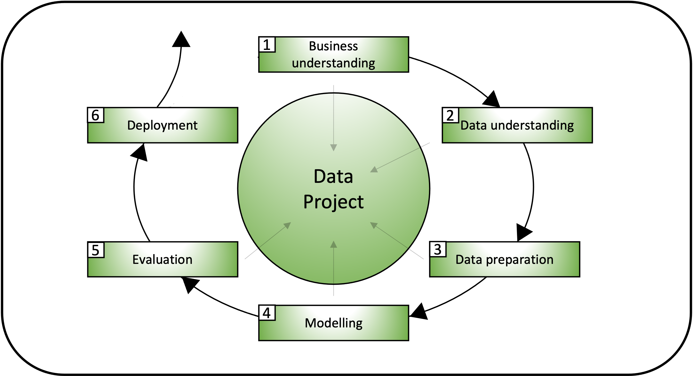

Figure 2.1: A schematic representation of the approach taken for this study using the CRISP-DM methodology**.** 1-Business understanding describes getting an overview of the business and/or organisation in question, describing the projected project goals and expected outcome. 2-Data understanding describes collecting the data, exploring it and describing it using statistical analysis and visualisation. 3- Data preparation describes preparing the data for modelling by cleaning and feature engineering making the available data suitable to be used in ML models. 4-Modeling describes choosing an appropriate model that that fits the initial question and the gained understanding of the data explaining the choice and the parameters set. 5-Evaluation describes evaluating the results and discussing them in line with the objectives of the projected outcome. 6-Deployment presented as a final report or software component, including the plan for deployment and how to monitor and maintain (Schröer, Kruse and Gómez, 2021).

**3.2 Project outline**



Figure 2.2: Outline of project

**3.3 Datasets**

The tweet dataset used for sentiment mining was generated as a deliverable of this project by collecting tweet data using the Twitter API basic access account paid for with personal funds. This allowed the mining of up to 10,000 tweets per month at a cost of 100 USD. The basic access only allowed access to recent tweets search which allowed collection of tweets from 7 days previous from the time of collection. The primary research generated a dataset used to compare sentiment in Ireland. Finally, the vaccination percentage dataset used to generate forecasting models was acquired from data.gov.

**3.4 Programming tools**

For statistics, data preparation/visualisation, and machine learning anaconda navigator was used along with Jupyter notebook as a coding interface. A number of python libraries were used to perform statistics, data visualisation and machine learning, these included: Pandas, numpy for data manipulation, stats, statsmodels for statistics and ARIMA models, sklearn for machine learning models, tensorflow and keras for neural networks such as LSTM and SimpleRNN, Matplotlib, Plotly, Seaborn for data visualisation. The language of choice for the project was python. All code files and outputs are provided alongside this report.

**3.5 Version Control**

In order to maintain work completed and store completed tasks necessary for the project a GitHub repository was set up. Commits where made on an iterative basis to save the progress of each step of the project so not to lose any progress made. GitHub link:

https://github.com/GavnDavisCCT/Masters_project_Covid19

**3.6 Collection of Tweet data using Twitter API and preprocessing**

**3.7 Machine learning and deep learning models**

A number of machine learning models were applied to the different datasets used in this project. For sentiment classification Random Forest Classifier, Multinomial Naïve Bayes Classifier, Support Vector Machine Classifier, Decision Tree Classifier, K-Nearest Neighbour Classifier, XG Boost Classifier, Extra Trees Classifier and LSTM models were used to predict sentiment.

**3.7.1 Decision Tree and Random Forest Classifier**

Random Forest Classifier is based on the Decision Tree model but instead of creating a single tree with multiple splits it creates a number of trees which operate as an ensemble, meaning the creation of more models to generate more accurate results (*Random Forest Algorithm for Machine Learning | by Madison Schott | Capital One Tech | Medium*, 2019). Both are supervised machine learning techniques. Each Tree predicts the class being predicted and the majority predicted class becomes he models prediction for that class. Like Decision Tree Classifier, Random Forest Classifier uses the Gini index to decide how each node branches in each of the decision trees shown in Eq.1 (*Random Forest Algorithm for Machine Learning | by Madison Schott | Capital One Tech | Medium*, 2019).

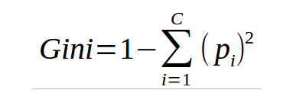

Equation 1: Gini index formula for calculating splits in decision tree classifier and multiple trees in Random Forest Classifier. This formula uses the class and probability to determine which of the branches is more likely to occur .

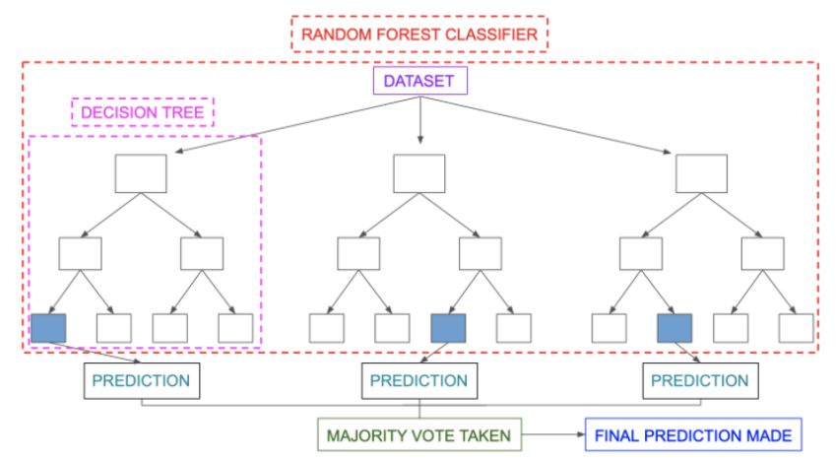

Figure 2.3: Schematic of random forest architecture and prediction method (*Random Forest Algorithm for Absolute Beginners in Data Science*, 2022)

**3.7.2 Naïve Bayes Classifier**

Naive bayes classifiers are based on Bayes Theorem assuming each point of data is completely independent taking into account whether probability of an event is True to make predictions about whether new data points are True. Multinomial Naïve Bayes is often used for Text Classification tasks. It also relies on bayes theorem which calculates the probability of an event B occurring given A has already occurred, as shown in Equation 2 (*Naives Bayes Classifiers for Machine Learning | by Madison Schott | Capital One Tech | Medium*, 2023).

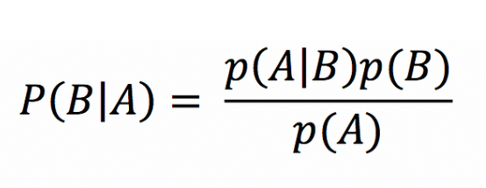

Equation 2: Naïve bayes probability calculation formula (*Naives Bayes Classifiers for Machine Learning | by Madison Schott | Capital One Tech | Medium*, 2023).

**3.7.3 Support Vector Machine**

Support Vector Machine or SVM is another excellent algorithm for classification tasks such as sentiment analysis. The algorithm generates a hyperplane in between data points in a dimensional space related to the number of features. The aim of algorithm is to generate a hyperplane with the largest margin meaning the largest threshold possible between similar groups of data points as shown in Figure 2.4 (*Support Vector Machine — Introduction to Machine Learning Algorithms | by Rohith Gandhi | Towards Data Science*, 2018).

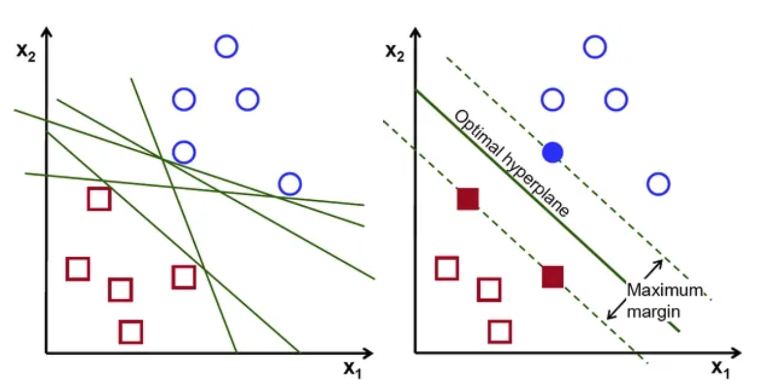

Figure 2.4: Data segregation in N-dimensional space to create a hyperplane using the SVM algorithm (*Support Vector Machine — Introduction to Machine Learning Algorithms | by Rohith Gandhi | Towards Data Science*, 2018).

**3.7.4 K-Nearest Neighbour Classifier**

K-Nearest Neighbour classifier is a simple supervised machine learning algorithm which classifies data based on proximity to other data points (Müller and Guido, 2016). The most important value to choose in KNN classifier is K the number of nearest data points or neighbours used to classify a point (*Machine Learning Basics with the K-Nearest Neighbors Algorithm | by Onel Harrison | Towards Data Science*, 2018). The KNN algorithm uses different equations for the measurement of distance between data points, the most commonly used is Euclidean distance which measures the straight line distance between two points in Euclidean space. Other measures include Manhattan and Minkowski (*Most Popular Distance Metrics Used in KNN and When to Use Them - KDnuggets*, 2023).

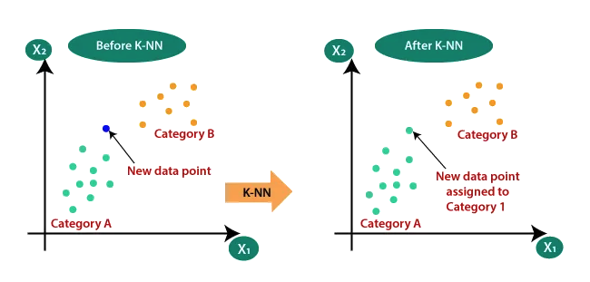

Figure 2.5: Classification of data point using K-Nearest Neighbour algorithm (*Machine Learning Basics with the K-Nearest Neighbors Algorithm | by Onel Harrison | Towards Data Science*, 2021).

**3.7.5 XGBoost Classifier**

XGBoost has gained massive popularity in the last number of years for classification tasks due to high precision, working on a similar premise to random forests, XGBoost is a form of ensemble learning that uses multiple models, also known as base learners (similar to Trees in random forest) to predict (*Beginner’s Guide to XGBoost for Classification Problems | Towards Data Science*, 2021). The Trees in XGBoost differ from those in random forest and are called CART Trees (Classification and regression trees). XGBoost harnesses by altering decision making based on decisions made with other trees and using gradient descent to isolate and remove trees which are poorly performing trees are isolated and removed. Through incorporating regularization XGBoost avoids overfitting, improving overall model performance, shown by consistently outperforming other machine learning models in predictive tasks. The speed at which the XGBoost algorithm work can be attributed to parrallelization which enables the boosting process to work in parrellel thus reducing the training time for the model (*XGBoost: Everything You Need to Know*, 2023).

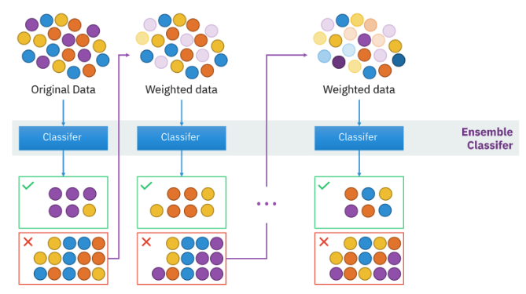

Figure 2.6: Schematic of XGBoost algorithm (*XGBoost: Everything You Need to Know*, 2023.

**3.7.6 ExtraTrees Classifier**

ExtraTrees Classifier or ETC is a supervised ensemble learning technique closely related to Random Forest algorithms, except for two key differences which distinguish the algorithms. Random Forest uses bagging to create different decision trees by selecting different variations of the training data (Geurts, Ernst and Wehenkel, 2006). In contrast, ETC uses the entire dataset to train the decision trees, which reduces bias in the model, how the manner in which the model chooses the node splits of the Trees is random which resultingly increase bias and variance. For this reason the model is best suited to datasets which do not contain many unnecessary features (*What? When? How?: ExtraTrees Classifier | by Karun Thankachan | Towards Data Science*, 2022). Due to the randomised selection of node splitting based on features in the ExtraTrees Classifier the computational cost is greatly reduced in comparison to other ensemble methods such as Random Forest, which can be a key advantage.

**3.7.7 Recurrent Neural Networks and Long Short Term memory**

Recurrent neural networks (RNN) are different from artificial neural networks (ANN) and convolutional neural networks (CNN) through creating a relationship between the independent and dependent variables, using a defined step (or time step) in a sequence of data to predict the following value during training, then taking this output forward to repeat the process (*What are Recurrent Neural Networks? | IBM*, Lalapura, Amudha and Satheesh, 2021). A schematic of how RNNs work is shown in Figure 2.7.

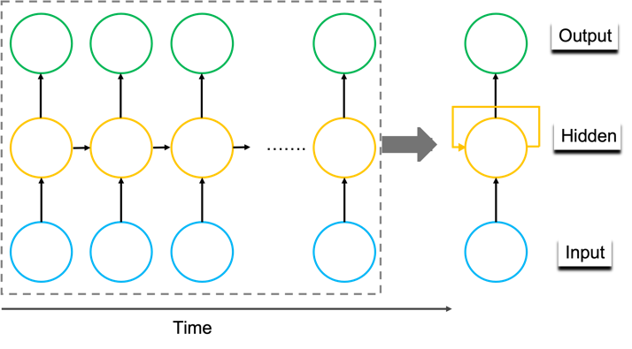

Figure 2.7: Schematic representation of RNN methodology**.**

Unlike other neural networks, backpropagation occurs at each time step known as back propagation through time (BPTT) adjusting and fitting the parameters of the model as it moves through each timestep (Lalapura, Amudha and Satheesh, 2021). This form of back propagation can lead to exploding gradients, where the gradient becomes too large leading to an unstable model, and vanishing gradients, where the gradient is so small as it updates it becomes insignificant and the algorithm is no longer learning (*What are Recurrent Neural Networks? | IBM*, ; *The Vanishing/Exploding Gradient Problem in Deep Neural Networks | by Kurtis Pykes | Towards Data Science*). LSTM architecture is more complex than standard RNNs which enables long term memory by using special gates known as the input gate, forget gate and output gate which facilitate the dropping of unimportant information and the retention of important information through the multiple nodes and layers of the model (*Understanding LSTM Networks -- colah’s blog*, 2015). These three gates protect and control the cell state of each node ultimately defining the output to the next node. The sigmoid layers in an LSTM generate values between 0 and 1, the closer to 0 means the information is less likely to make it through, while the closer to 1 means it will make it through to the output layer (*Understanding LSTM Networks -- colah’s blog*, 2015). LSTMs have been applied to several different types of data and have been used in the weather prediction, stock market prediction and even has been applied to Covid19 data to predict the spread in different countries (Braun, 2018; Qiu and Fan, 2021; Chandra, Jain and Chauhan, 2022; Srivastava and Anto, 2022).

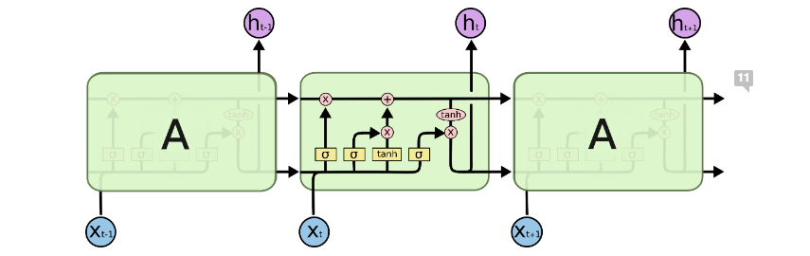

Figure 2.8: Architecture of LSTM. As shown in the central node the information much pass through the three types of gates present in an LSTM node thus dictating whether the information will be passed to output and make it to the next node (*Understanding LSTM Networks -- colah’s blog*, 2015).

**3.7.8 Auto Regressive moving average**

Auto regressive integrated moving average models or ARIMAs work on a similar premise to other time series models in that they use past values, also called lags or lagged forecast errors, to predict future values (*Introduction to ARIMA for Time Series Forecasting | by Juan Nathaniel | Towards Data Science*, 2021). ARIMA models are generated by using 3 key values, p, q and d. P is related the autoregression portion of the model which uses past values to generate a regression model to assess the relationship with the current model. The d term is concerned with differencing by subtracting the past value from the current value to make the time series stationary and removing seasonality. The general ARIMA equation is shown in Equation 3.

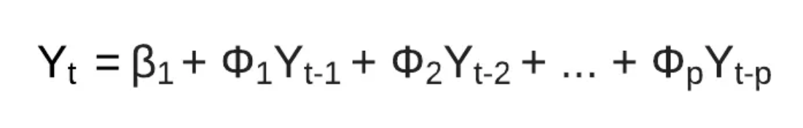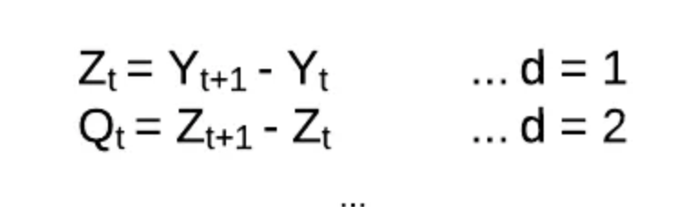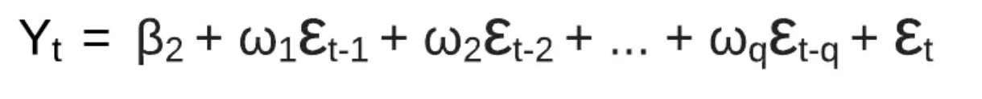

(A)

(B)

(C)

Equation 3: General ARIMA equation. (A)Y is an observation at time t, where Yt-p represents the number of lagged observations or past values included in the model. (B) Shows the hyperparameter d of an ARIMA model where by stationarity is introduced to the model by subtracting past values. This can be done numerous times to achieve stationary data to which the model can be successfully applied to. (C) Shows the residual error ε from the aggregation function, where q specifies the time window for the residual error of the moving average (*Introduction to ARIMA for Time Series Forecasting | by Juan Nathaniel | Towards Data Science*, 2021).

**3.8 Model performance metrics**

A number of industry standard metrics were used to evaluate the performance of the machine learning model. This metrics deal with the evaluation step 5 in the CRISP-DM project management framework.

$$Accuracy=\frac{TP+TN}{TP+TN+FP +FN}$$

*TNeu*

*TNeg*

*TP*

*FNeu*

*FNeu*

*FNeg*

*FNeg*

*FP*

*FP*

*Actual values*

*Predicted values*

*Neutral*

*Negative*

*Positive*

*Neutral*

*Negative*

*Positive*

Figure 2.9: Shows the equation for accuracy for a binary classification task along with the confusion matrix for a multi-class (3) classification task such as the models presented in this study

$$Precision=\frac{TP}{TP+FP}$$

$$Recall=\frac{TP}{TP+FN}$$

$$F1 score=2*\frac{Prercision x Recall}{Precision+Recall}$$

Figure 2.10: Shows the model evaluation metrics used to assess the performance of the machine learning models presented in this project.

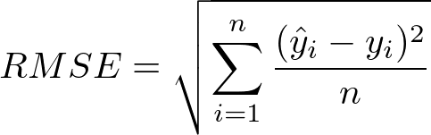

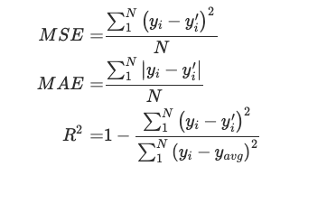



Figure 2.11: Shows the formulas alternative model evaluation metrics used to measue the accuracy of the models presented in this project**.**

**2.9 Sampling strategy**

The sampling strategy for the primary research carried out in this project was **non-probability sampling**. The entire population of Ireland was affected by the covid 19 pandemic and therefore taking a sample from the population using the **convenience sampling type** should yield reflective data. Convenience sampling allows to collect data from populations which are close at hand. Given the timeframe of the project and that the entire population of the country was effected by the topic area, convenience sampling was chosen to be the primary sampling type. The main aim of the survey is to collect peoples sentiment data about the opinion towards vaccines from a sample of the Irish population. Given the entire population was effected by the topic area being examined in this project people close to hand were chosen to complete the survey to acquire the data within the time frame of the project. It is the aim to acquire 40 responses to the survey. In total, 47 response were recorded to the survey.

A sub aim of the survey is to correlate different survey answers with vaccine sentiment such as employment area, and hesitancy to gain insights into potential drivers of sentiment and or vaccine hesitancy. Data analytical approaches were key during the pandemic for uncovering such correlations to inform decision making and vaccine awareness. Thus this quantitative analysis aims to contribute to the body of knowledge by using statistical and visualisation methods. In light of this, **purposive sampling** will also be incorporated into this sampling process, given a number will be selected from both scientific/health and non-scientific/health backgrounds to acquire survey responses. Purposive sampling allows the researcher to purposefully choose subjects for the primary research which they believe align with the objectives of the study. It is primarily used in qualitative research to gain insight into the area of interest, however in this case, given it is known that the entire population was effected by the topic area, it could be hypothesized that the data collected could be reflective of the wider population to generate some insight. Given the intended sampling size this cannot be confirmed, but in applying quantitative methods to the data collected some suggestive insights may be generated about the wider population in relations to vaccine sentiment and hesitancy. The hypothesis of this sub aim is that employment background may contribute to hesitancy and/or vaccine sentiment with relatively low amounts of literature citing employment background as a contributor to vaccine sentiment and hesitancy. Again purposive sampling, enables the quick and easy collection of data based on particular things the research believes to be relevant to the populations at hand. This sampling methodology may be used in wider studies where the sample size can be expanded.

**2.10 Primary research methodology**

The primary research was performed using a carefully designed and simple survey. The preliminary considerations for the survey design were, what information will be gathered that will help achieve RO2 of the project, which is to evaluate the current vaccine sentiment of a cohort of people in Ireland. Extending this it was a sub aim to understand whether distinct subgroups understand whether there is a difference in sentiment and awareness within people from different employment backgrounds. The target audience will be people who received the covid19 vaccine or did not, and will be chosen in a non-discriminatory fashion except for one caveat, which is, an attempt will be made to have the survey completed by people from both non-scientific/health and scientific/health employment backgrounds to assess whether there are differences in their views on vaccines and/or the sentiment around vaccines. This is an example of the purposive sampling which was discussed in the last section to evaluate the hypothesis that employment background may contribute to vaccine uptake and hesitancy. The idea for this hypothesis comes from the fact that in most cases peoples working in science and health areas have a better understanding than those who are not in relation to vaccines, thus potentially contributing to their sentiment and hesitancy. Given the type of information being asked could be considered sensitive, people will be asked if they are comfortable answering questions on the topic of covid19 vaccine prior to administering the questionnaire. Given the potential sensitivity of the topic the survey will be anonymous to allow people give reflective information and their identity safeguarded. The survey was developed on an online platform known as Survey Monkey and sent out via email/message which could be completed on a computer or phone. The design was simple but professional, with the length being kept to a minimum while also obtaining the level of information required by the study. The title was carefully chosen so not to dissuade or lead any potential responders to bias the information gathered.

Each question was designed to add value to the information gathered to be used in the analysis of the data, comparisons and correlations can be made through gathering answers to different questions, such as, correlating age with hesitancy (Question 2 with 6). No person which the survey was administered to will be unable to answer any question. The response to the questions will be closed-ended and multiple choice so to stream line responses and gather consistent usable data. Some responses may be dichotomous, either yes or no. The closed ended response made the qualitative and quantitative analysis easier, and reduced the introduction of any error, making all responses between subjects comparable. The questions were designed to be simple, non-leading, non-loaded and understandable for a wide audience to maximize the level of accurate responses. The sequence of questions will be considered so to guide the subject through the questionnaire in the most comfortable way possible. The most sensitive and important questions will be placed near the end and the subject will be thanked for their responses. After the survey was fully designed was pretested before actually carrying out the study to identify any potential unseen issues and amend them.

It was the aim of this primary research section to gather at least 40 responses to the survey, with 47 response recorded. The survey was not sent out cold as indicated by the sampling strategy and type, and was administered to a populations which is close to hand, as outlined in the sampling methodology.

**Survey questions:**

1. What age bracket do you fall under? (discussion point in findings about age and vaccine hesitancy and awareness)
2. Which country were you born?   (correlating with other answers, easy lead in question)
3. How many people, including yourself, live at home with you? (discussion point in findings about whether people who live in larger homes were more or less hesitant)
4. Which option ***provided*** does your profession fall under? (Broad range of titles supplied, other option given with a follow up question asking to describe profession)
5. If you answered other to the last question, could you describe the area you work in?
6. Have you received a covid19 vaccine? (yes/no/rather not say)
7. Were you hesitant to receive a covid19 vaccination? (yes/no/rather not say)
8. Did you understand how vaccines worked prior to the pandemic? (Yes/no)
9. How would you describe your understanding of vaccines post pandemic compared to pre pandemic? (Very good, good, okay, poor, very poor)
10. Would you like to understand how vaccines work so that you can understand the effect they may have on you? (yes, no, impartial)
11. In your opinion, was the level of public awareness raised around vaccines was sufficient during the pandemic?(Will give 5 options, very good, good, okay, poor, very poor)
12. Were another pandemic occur, would you be likely to receive a vaccine were another pandemic to occur? (yes/no/rather not say)
13. Which option best describes your feelings towards vaccines? (very positive, positive, neutral, negative, very negative)

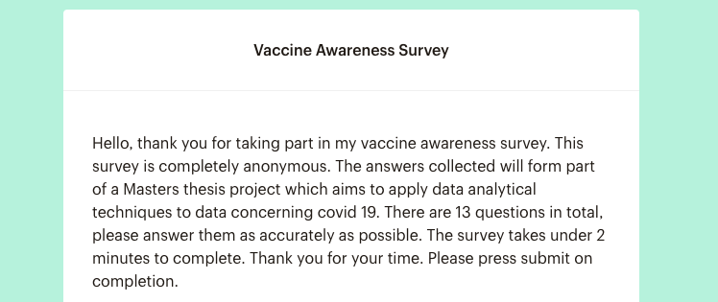

Figure 2.9: Introduction to the survey sent out via email to participants

**4.Results**

**4.1 Sentiment analysis of covid 19 tweets**

**4.1.1 Collection and pre-processing of Tweet data**

Tweepy was used to extract tweets from Twitter on covid 19 vaccines. The query was “ covid-19 vaccine”. As previously described in the methodology section, the Twitter API basic access only allowed for access to 7 days previous , using the ‘search_recent_tweets” method. The Tweepy paginator was using to gather more than the max results parameter limit of 100, setting the limit to 10,000. This enabled the collection of 5,620 tweets. Before preparing and cleaning the tweet data for sentiment analysis, the dataset was explored to remove null values or duplicated tweets. The dataset was reduced from 5,620 to 5,515 after removal of duplicates present. The tweet data was prepared for sentiment analysis by performing a number of operations to clean the textual data. These included removing converting to lowercase, removing special characters such as hashtags, removing stop words, removing URLs, converting multiple spaces into single spaces. The removal of stop words was enabled by NLTK library. After this Porterstemmer was used to stem the respective words into common rudiments thus reducing unwanted noise in the data.

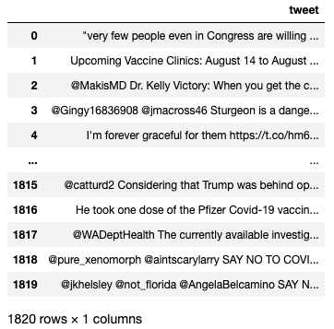

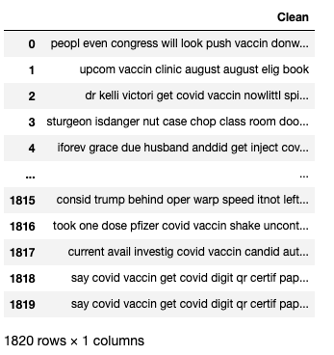

Figure 4.1: Unclean vs clean tweet data after pre-processing with NLP techniques

**4.1.2 Calculating tweet polarity using TextBlob and VADER**

After the necessary text preprocessing steps, TextBlob and VADER were used to assess the polarity of the cleaned textual data. Both are lexicon based methods however VADER is said to be more accurate for calculating polarity of social media content (*TextBlob vs. VADER for Sentiment Analysis Using Python | by Amy @GrabNGoInfo | Towards AI*, 2022). As shown in Figure 4.2, the TextBlob and VADER polarity measurements differ greatly particularly in the magnitude of positive and negative polarity. VADER appears in most cases to accentuate the magnitude of positive and negative polarity as compared with TextBlob, an interesting difference, which could be connected with the enhanced ability of VADER to calculate polarity of social media data.

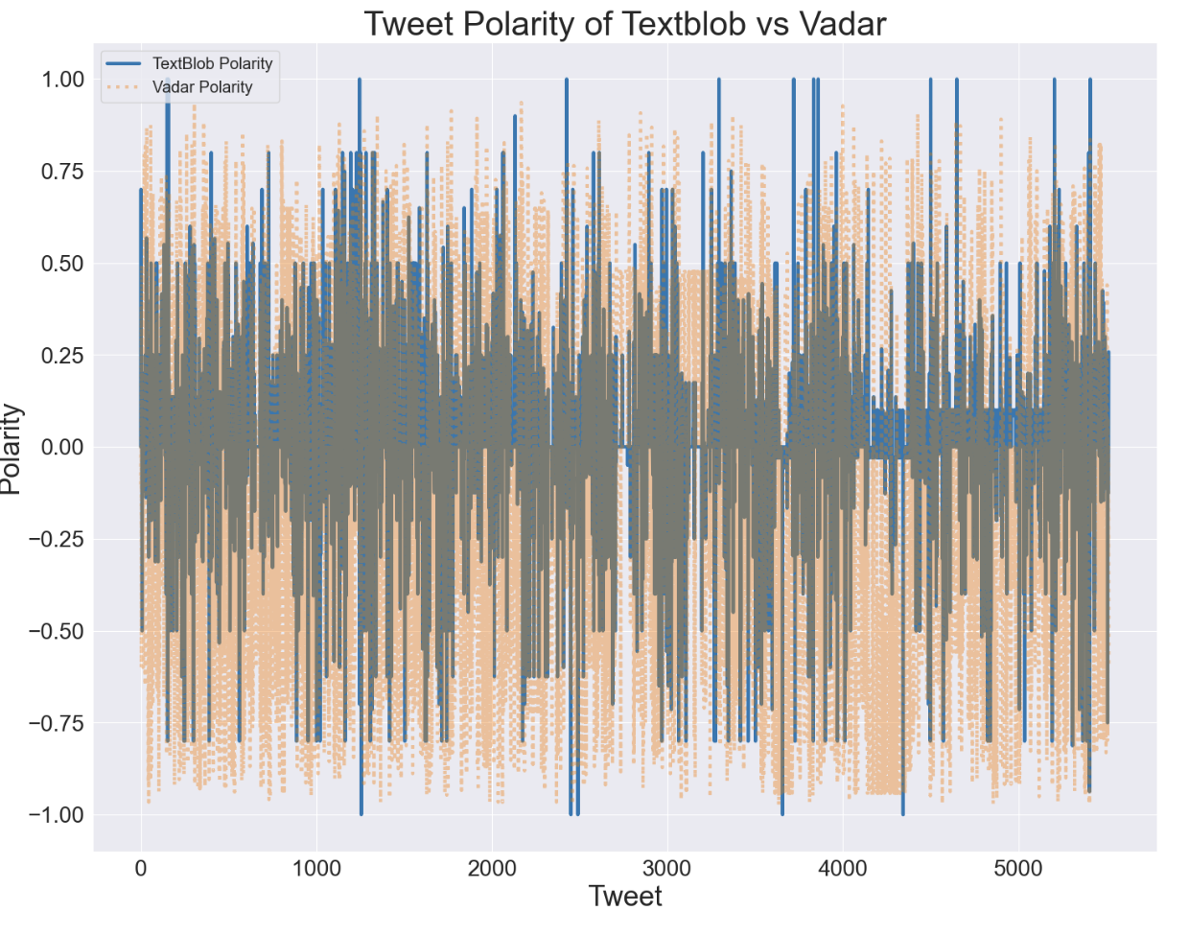

Figure 4.2: Comparison of polarity measurement of covid 19 tweets using TextBlob and VADER.

**4.1.3 Assessing the weight of positive, negative and neutral tweets in the dataset**

After pre-processing the tweet data and calculating the polarity of the cleaned tweet data using TextBlob and VADER, an in depth analysis to understand the distribution of positive negative and neutral sentiment amongst the tweets was performed. To do this a number of visualisation were generated using plotly and WordCloud. Figure 4.3 and 4.4 show a bar graph and pie chart which highlights the number and percentage of positive, negative and neutral tweets as calculated by TextBlob and VADER. As shown in Figure 4.3, the overriding sentiment calculated by TextBlob is neutral (45.3%), followed by positive (34.6%), with negative (20.1) being the lowest sentiment class. In sharp contrast Figure 4.4 shows the distributions of sentiment as calculated by VADER with negative (48.5%) being the overriding sentiment, followed by positive (26.3%), followed by neutral (25.2%). This is an interesting distinction, and shows that TextBlob and VADER differ in their sentiment caluclations this covid 19 tweet dataset. Upon inspection of the word clouds generated for both sentiment polarity calculation methods, shown in Figure 4.5 and 4.4, it can be seen that there is a clear distinction in the words which are being identified as positive, negative and neutral between the two methods.

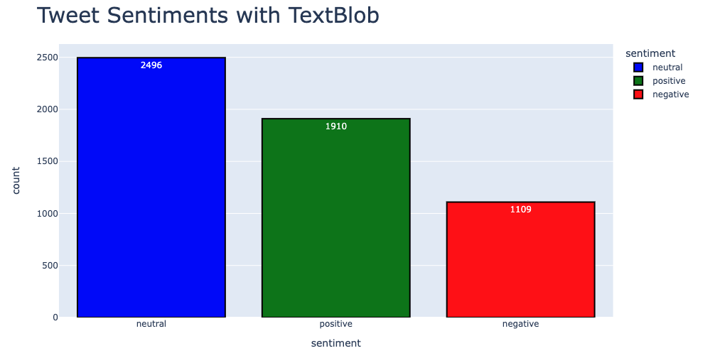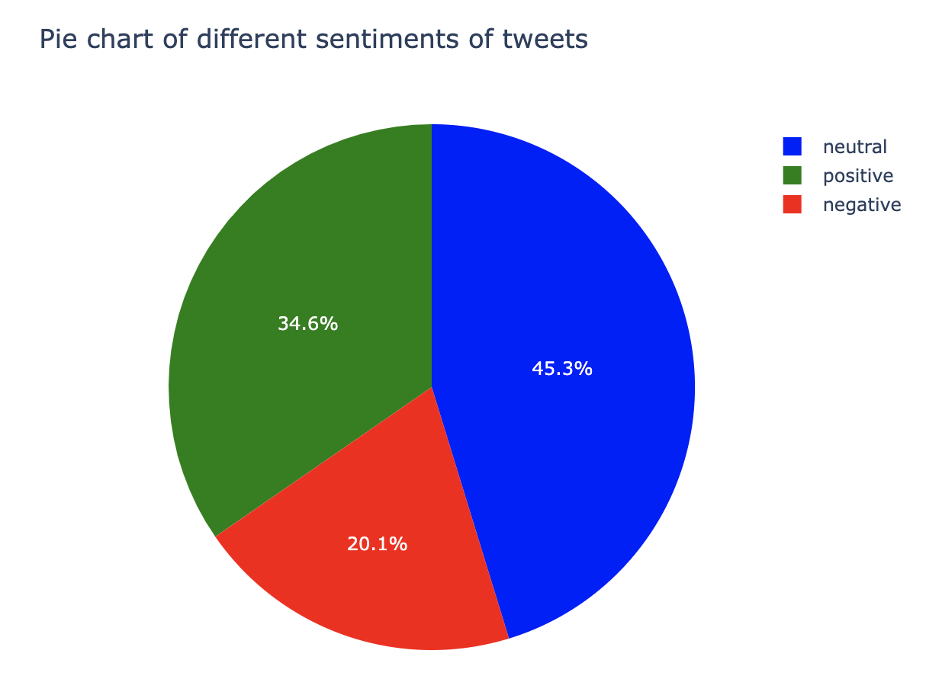

Figure 4.3: Distribution of Positive, negative and neutral tweets using TextBlob.

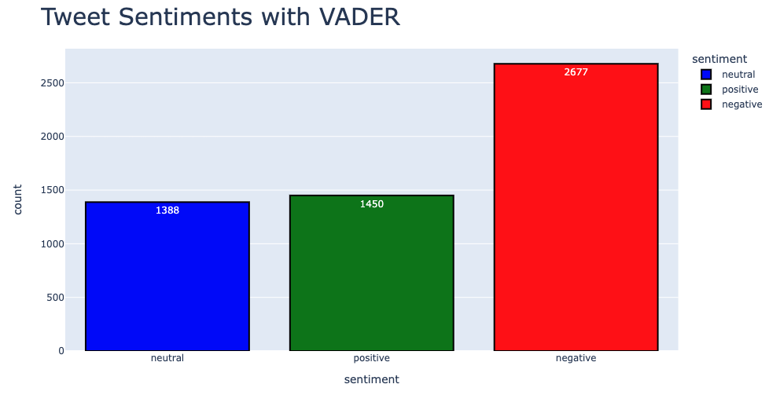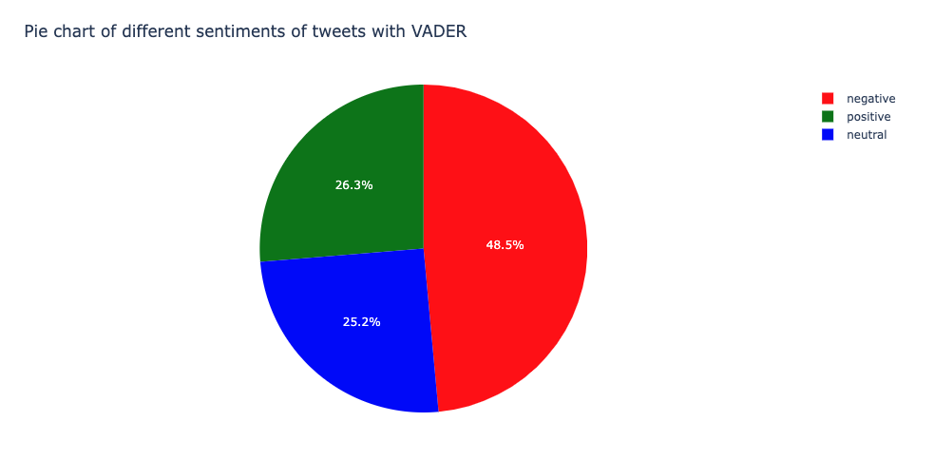

Figure 4.4: Distribution of Positive, negative and neutral tweets with VADER.

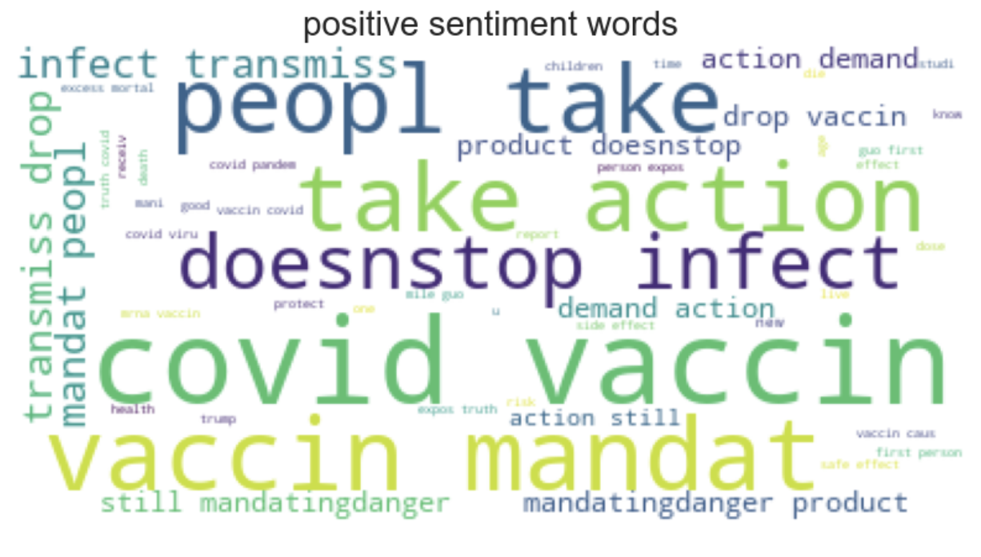

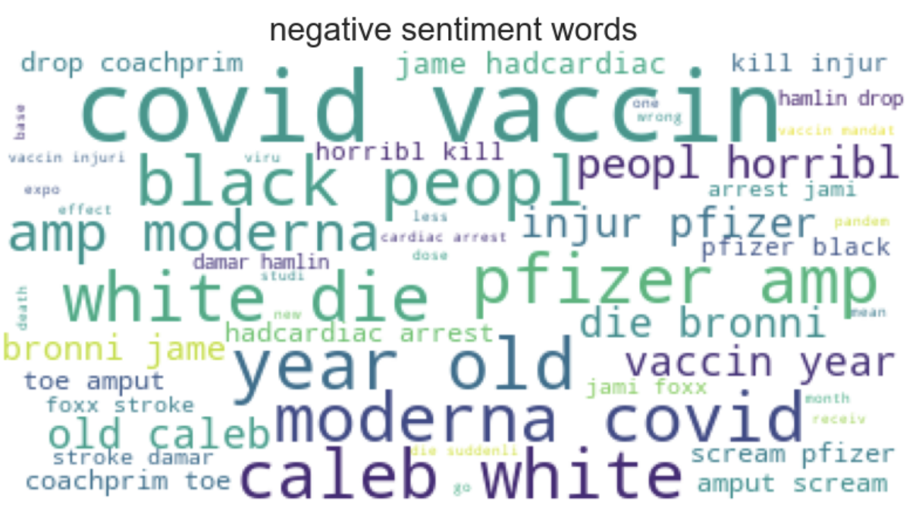

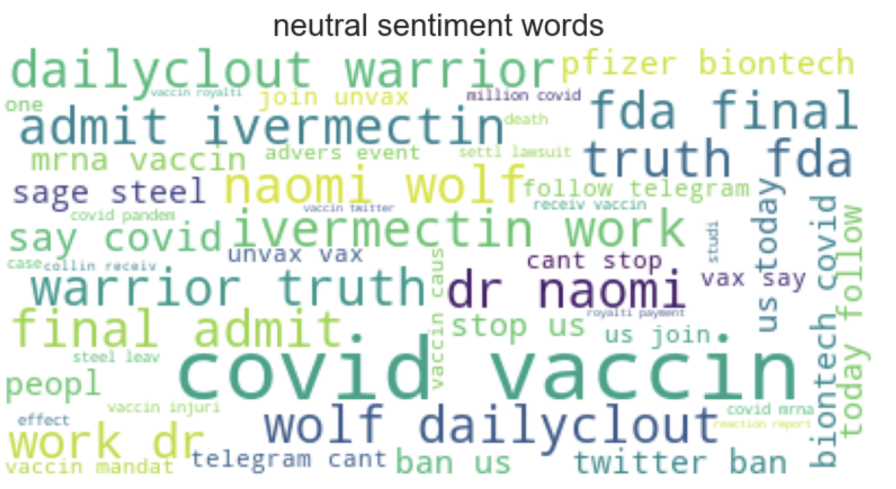

Figure 4.5: WorldCloud of Positive, negative and neutral tweets with TextBlob.

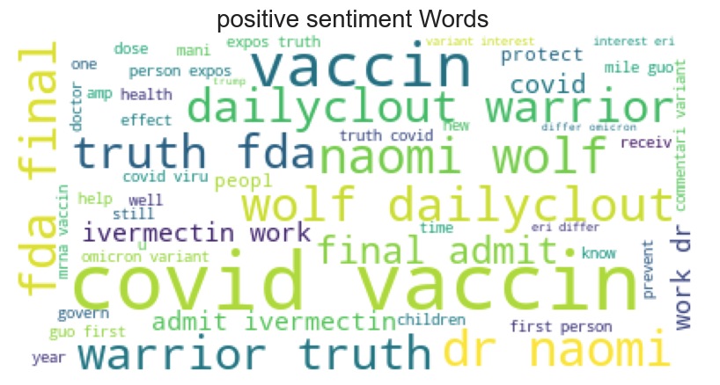

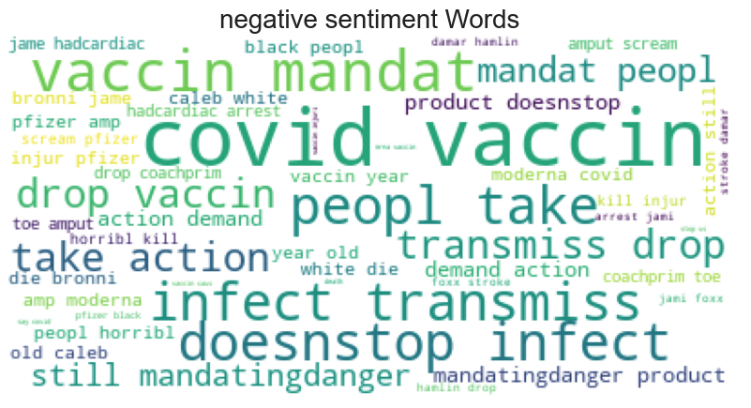

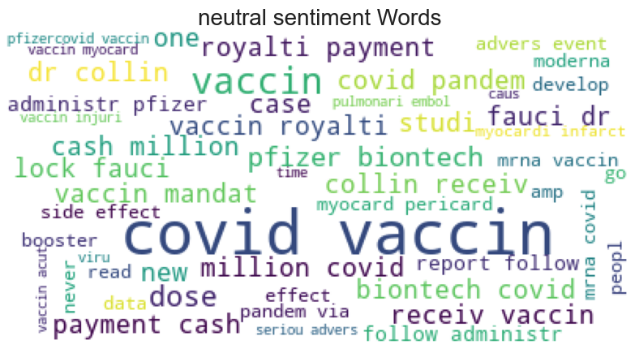

Figure 4.6: WordCloud of Positive, negative and neutral tweets with VADER.

**4.1.4 Implementation of machine learning models for tweet sentiment classification using TextBlob and VADER sentiment datasets**

After calculating he sentiment polarity scores with TextBlob and VADER and assigning positive, negative and neutral sentiment to each tweet in the dataset. Machine learning models were explored and implemented to generate accurate classification models trained on the covid 19 tweet dataset to predict sentiment. To do this, a number of machine learning models were trained using the dataset, firstly on the TextBlob sentiment classification method. As shown in section 4.1.3, the overriding sentiment in the TextBlob dataset was neutral, followed by positive, with the lowest being negative. To train the machine learning classification models the cleaned tweet data was vectorised using the TF-IDF vectorization technique from sklearn to represent works as numeric type. To implement the TF-IDF, the data was split, labelling the tweet text data as ‘X’ and the sentiment as ‘y’. The sentiment was encoded using a lambda function to assign a value of 0 to neutral, 1 to negative and 2 to positive to allow use in the machine learning model. TF-IDF was applied to the clean tweet data using a max_features = 3000, analyzer = word, ngram_range = (1,3) and stop_words = English. After vectorization he data was partitioned into training and testing data using sklearns train_test_split, with a test size of 0.1 or 10% and a random_state =0. A for loop was created to apply seven different classification models to the data and make predictions. The for loop included print statements to produce the relevant model metrics to assess the accuracy, precision, recal and F1-score of the models. The models applied to the data were Random Forest Classifier, Multinomial Naïve Bayes Classifier, Support Vector Machine Classifier, Decision Tree Classifier, K-Nearest Neighbour Classifier, XG Boost Classifier and Extra Trees Classifier. Classification reports were printed for each of the models and recorded as seen in Table 4.1. Confusion matrices were generated for the predictions of each model as shown in Figure 4.7. Figure 4.8 shows the summary of model accuracies obtained for each model after training and prediction with the TextBlob sentiment dataset. The model with the highest accuracy of 0.91 or 91% was the Extra Tress Classifier followed by the XG Boost Classifier.

To evaluate whether deep learning techniques such as LSTM which have been extensively applied in the literature for sentiment classification could achieve a greater accuracy than the previously implemented models, the data was prepared for implementation into an LSTM model. To use the data to train an LSTM model, further processing steps were required including tolkenizing the tweet into lists of single words, following this the length of each tweet was assessed to include a pad sequence to define the limit for all input texts, as the LSTM requires all to be the same length. The assessment of tweet length can be seen in Figure 4.9 using descriptive statistics and histograms to visualize the length of positive, negative and neutral tweets. A max word length of 50 was chosen for the LSTM implementation. Dummie variables were used to enumerate each sentiment class by using get_dummies. The data was split as before with sklearn train_test_split with a test size of 10% and a random_state = 0. TF-IDF was used to vectorize the tweet data and pad sequences were tolkenized using sklearn.tolkenizer. At this point the train, test and validation sets were generated. The LSTM architecture consisted of an embedding layer, including the vocab size, embedding size and input length corresponding to the max word length.The embedding layer is necessary to transform high-dimensional categorical data into a lower dimensional format allowing the model to learn more easily. Next was a Convolutional 1 D layer to smoothen the input with 32 filters and an activation of relu. A max pooling layer was included, followed by a Bidirectional LSTM layer with 32 neurons. A dropout of 0.4 was chosen for accounting for errors in the model and a final dense output layer of 3, with a softmax activation. The compiling step specified the loss function of ‘categorical _crossenthropy’, and the optimizer which included the vocab size related to the corpus used to train the model and the learn rate. The model was run over 20 epochs with a batch size of 32. The LSTM achieved an accuracy of 0.9 or 90%. The confusion matrix and model accuracy/loss curves can be seen in Figure 4.10.

Taken together these results indicate that the Extra trees Classifier model had the highest accuracy for the TextBlob sentiment dataset, followed by the XGBoost Classifier and LSTM.

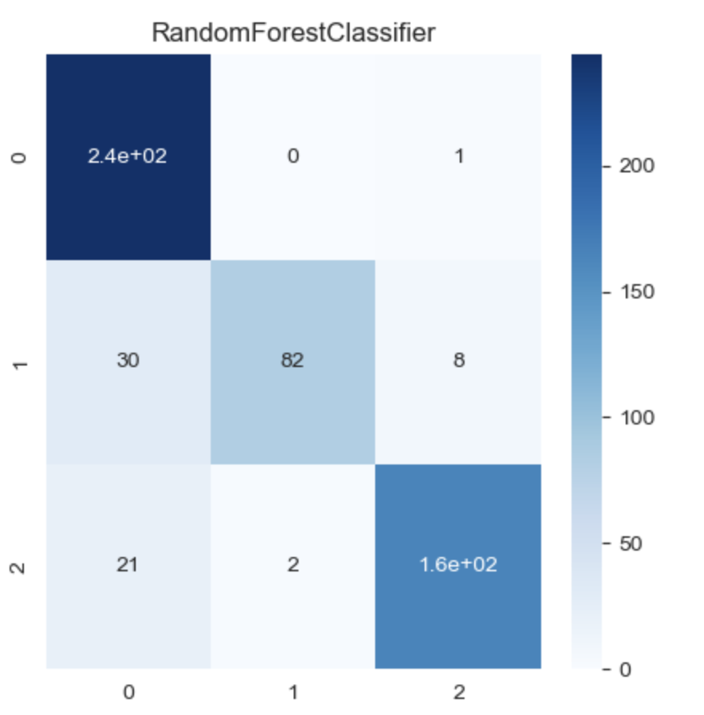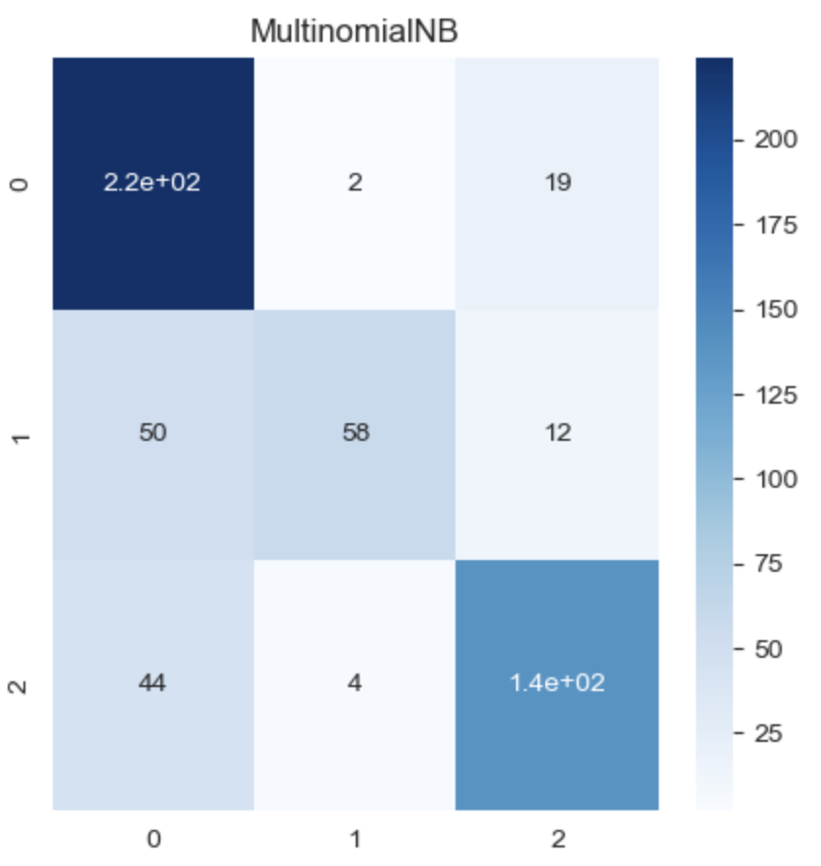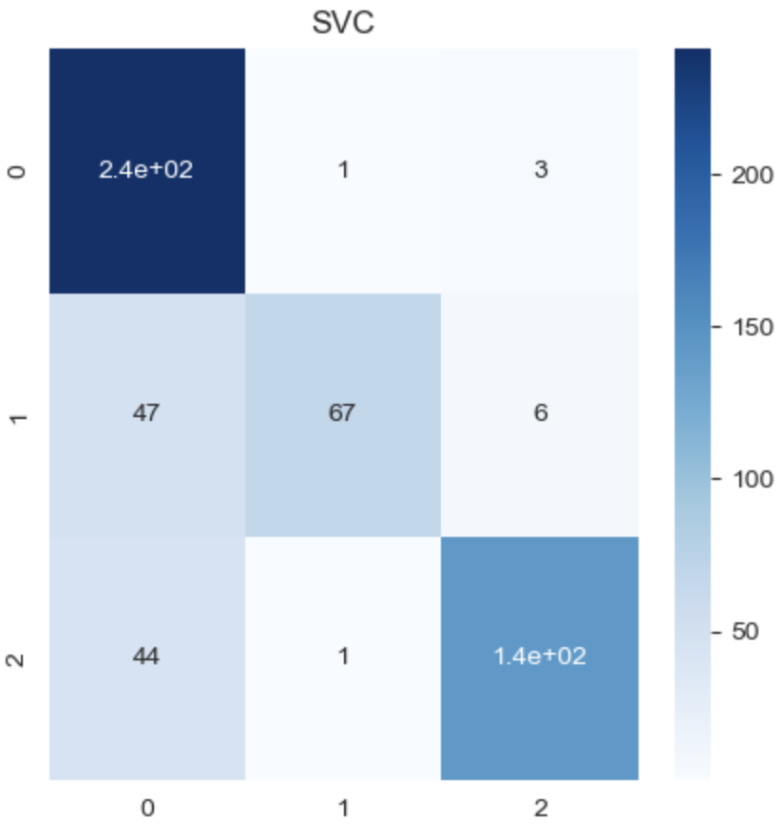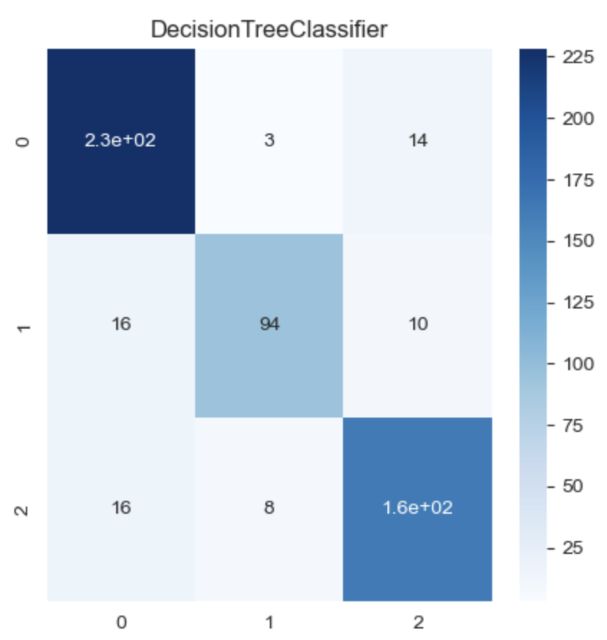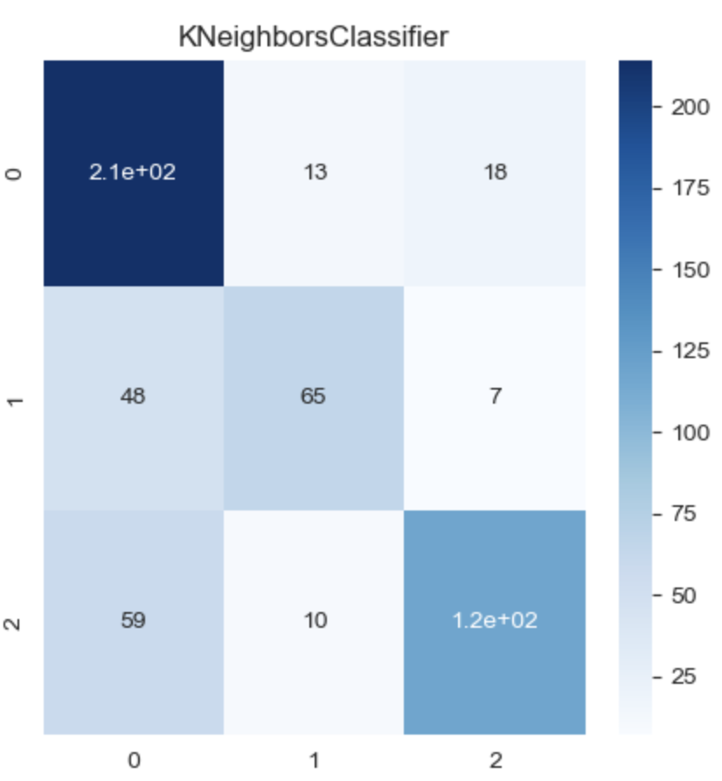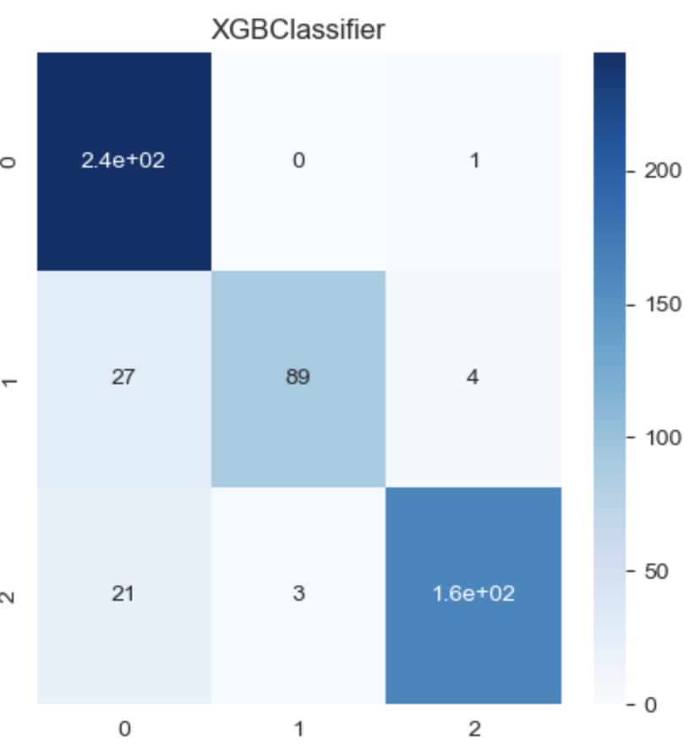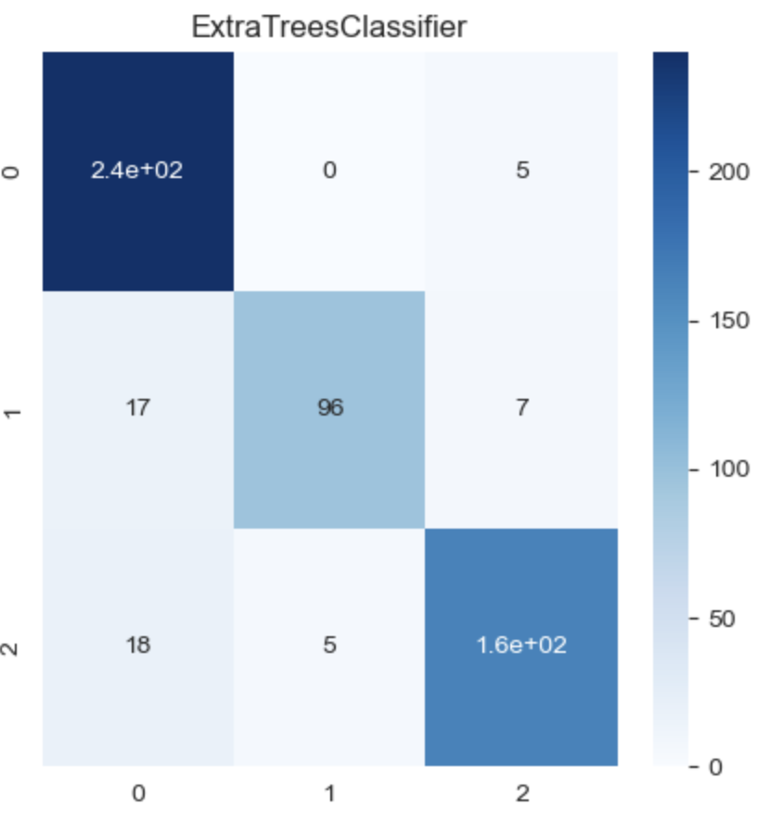

A

B

C

D

E

F

G

Figure 4.7: Confusion matrices showing correctly predicted positive, negative and neutral tweets using different machine learning classification models using TextBlob sentiment.

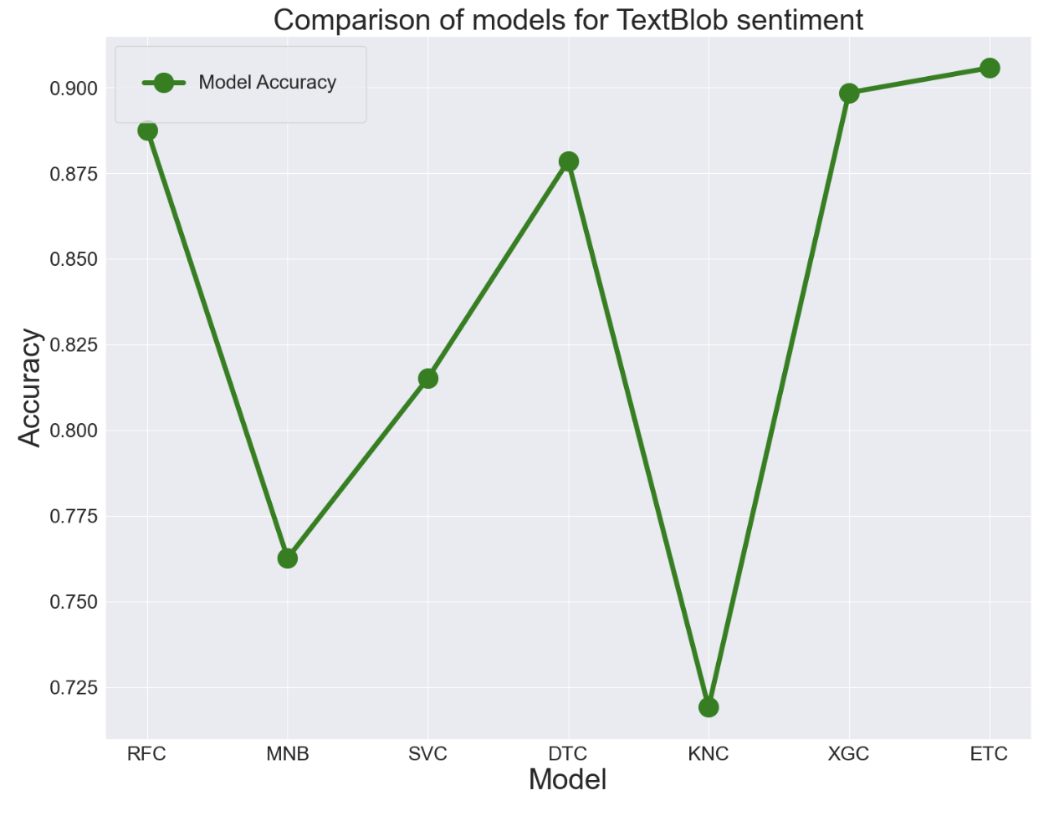

Figure 4.8: Summary plot of model accuracies for classifier models using TextBlob.

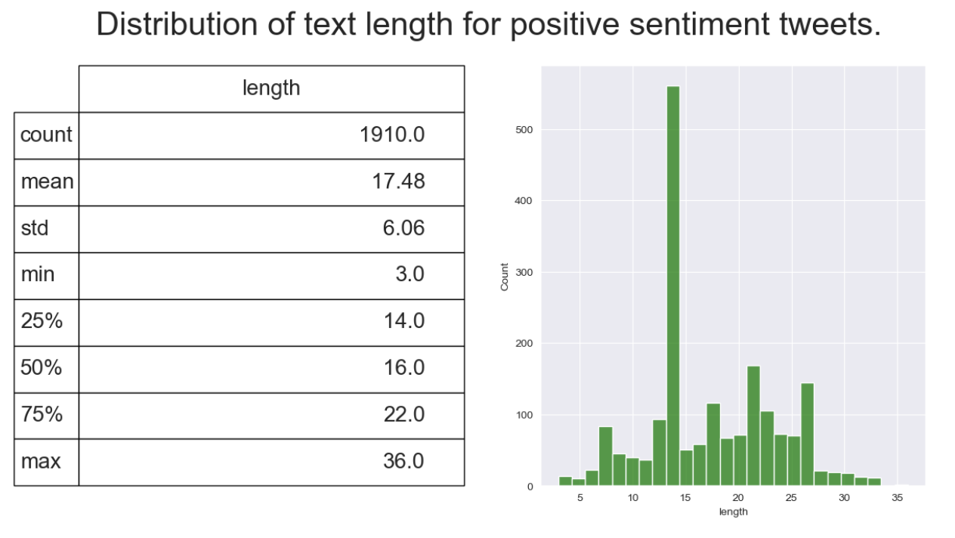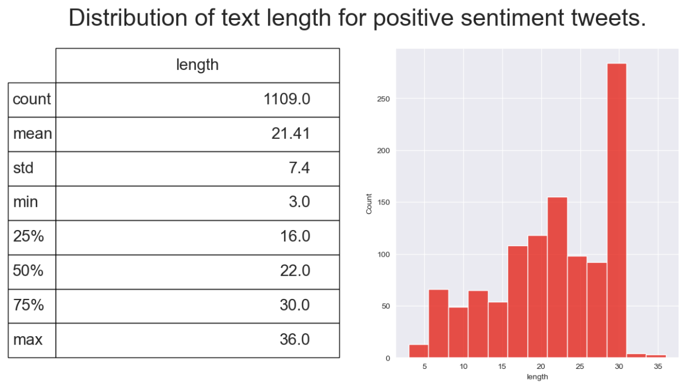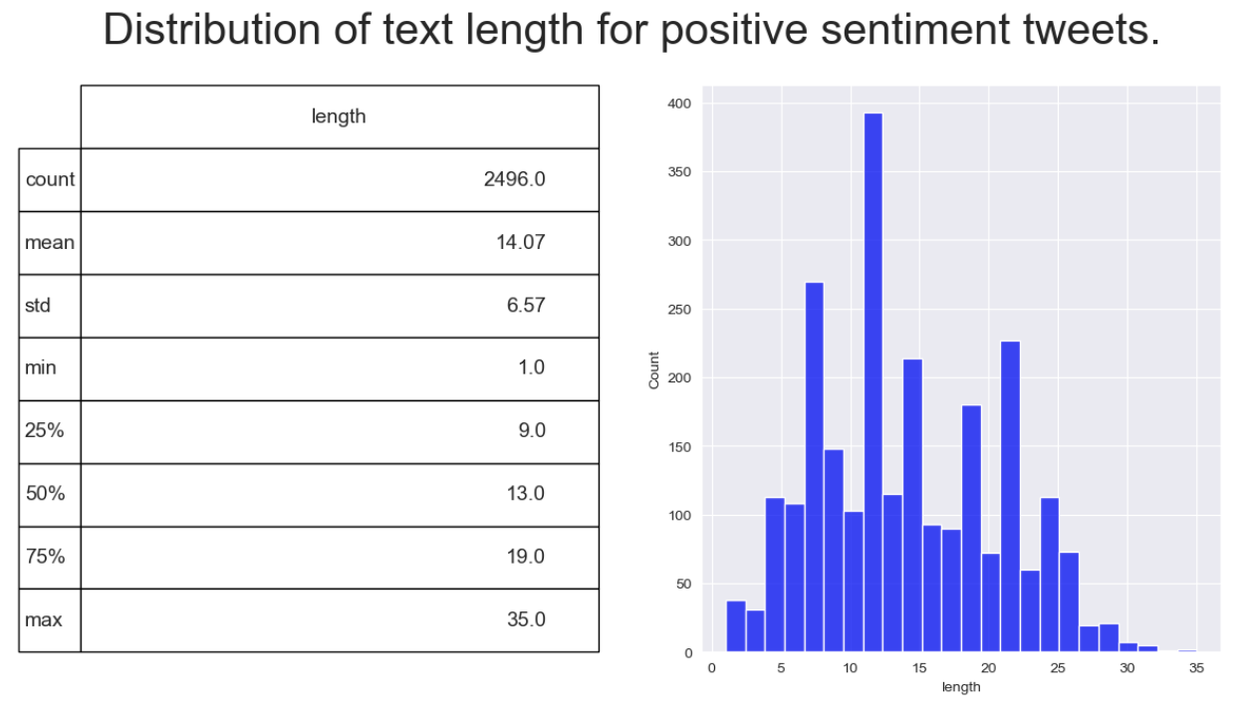

A

B

C

Figure 4.9: Distributions of positive, negative and neutral tweet word lengths and descriptive statistics for each sentiment for TextBlob sentiment.

B

A

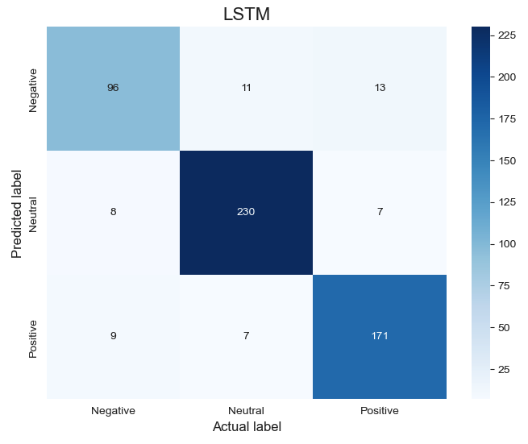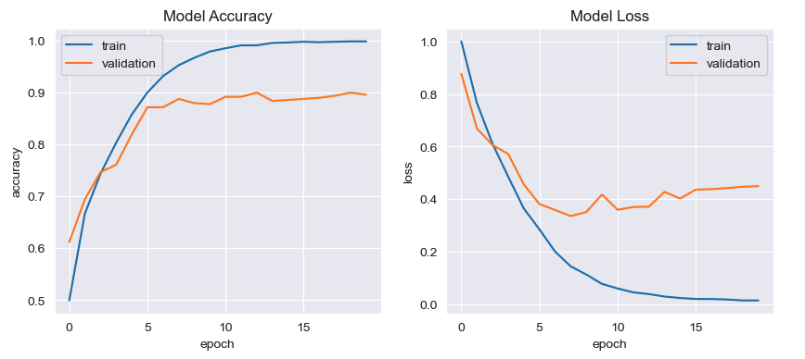

Figure 4.10: Confusion Matrix for correctly predicted sentiment using LSTM and Model accuracy/loss curves for training and validation for TextBlob sentiment.

**4.1.5 Implementation of machine learning models for tweet sentiment classification using VADER sentiment**

In the same manner as Section 4.1.4, the same set of machine learning models were applied to the VADER sentiment dataset to compare model accuracies with the TextBlob sentiment dataset. Models were implemented as previously described in Section 4.1.5. Figure 4.11 shows the confusion matrices for the classification models Random Forest Classifier, Multinomial Naïve Bayes Classifier, Support Vector Machine Classifier, Decision Tree Classifier, K-Nearest Neighbour Classifier, XG Boost Classifier and Extra Trees Classifier. The Extra Tress Classifier was the model with the highest accuracy of 0.91 or 91%. The comparison of model accuracies can be visualised in Figure 4.12. As with the TextBlob sentiment dataset, word length was assessed, shown Figure 4.13, for implementation of the LSTM model. The LSTM architecture was the same as described in Section 4.1.4. The model achieved an accuracy of 0.84 or 84%, 6% lower than the accuracy achieved with the TextBlob sentiment dataset LSTM model. The confusion matrix for predictions of the LSTM with the VADER tweet dataset can be seen in Figure 4.14 , along with the accuracy and loss curves for training and validation. A summary of model accuracies for the TextBlob and VADER sentiment datasets can be seen in Table 4.1. Overall, model performances were similar for each classification model except the LSTM. There are also notable differences in accuracy in the Random Forest Classifier and XG Boost Classifier which will be discussed in Section 5.

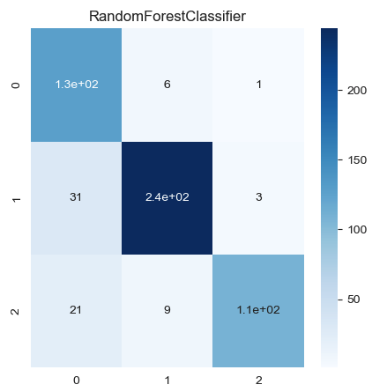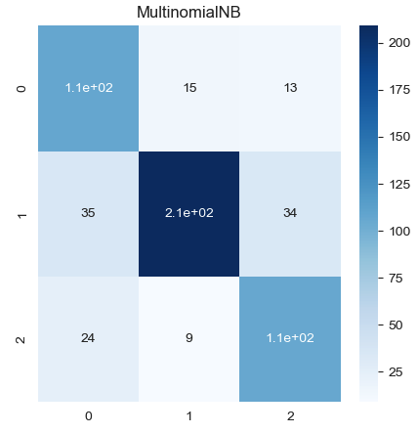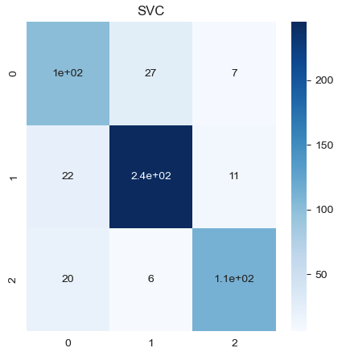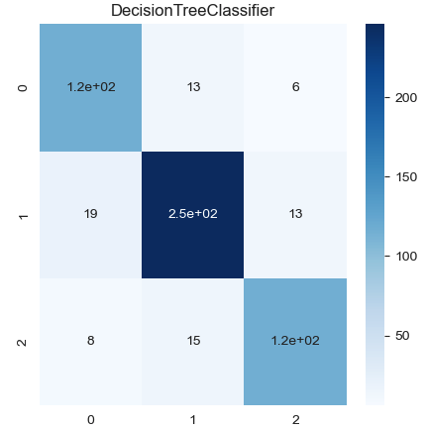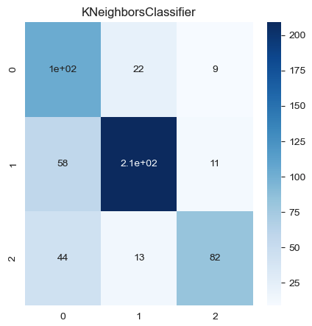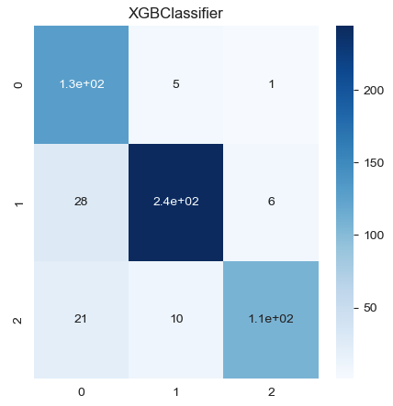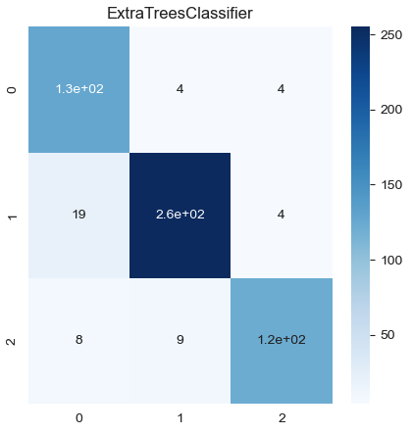

A

B

C

D

E

F

G

Figure 4.11: Confusion matrices showing correctly predicted positive, negative and neutral tweets using different machine learning classification models using VADER sentiment.

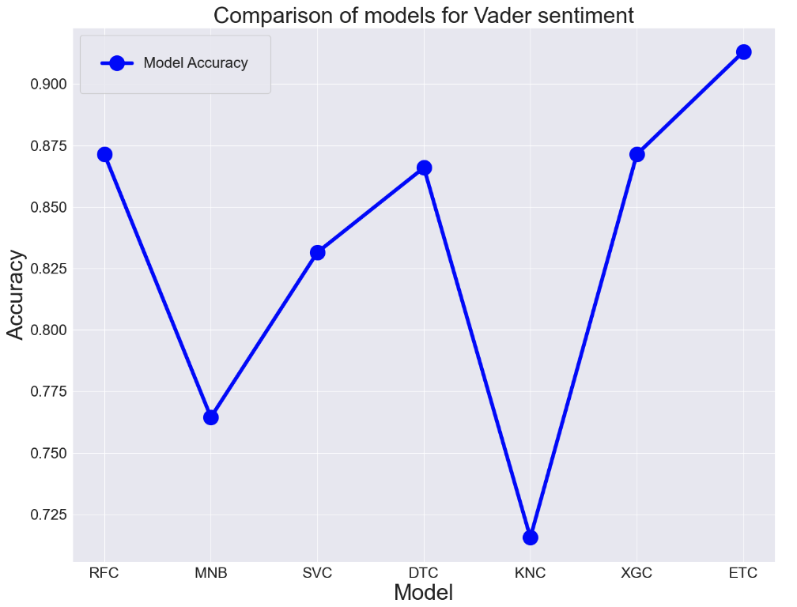

Figure 4.12: Summary plot of model accuracies for classifier models using VADER.

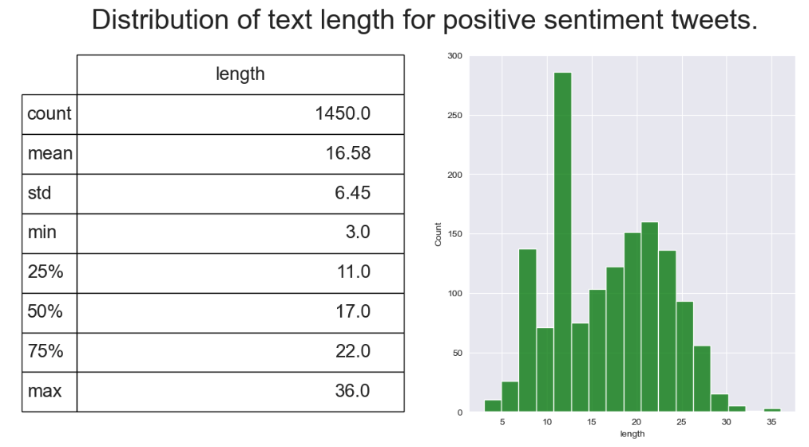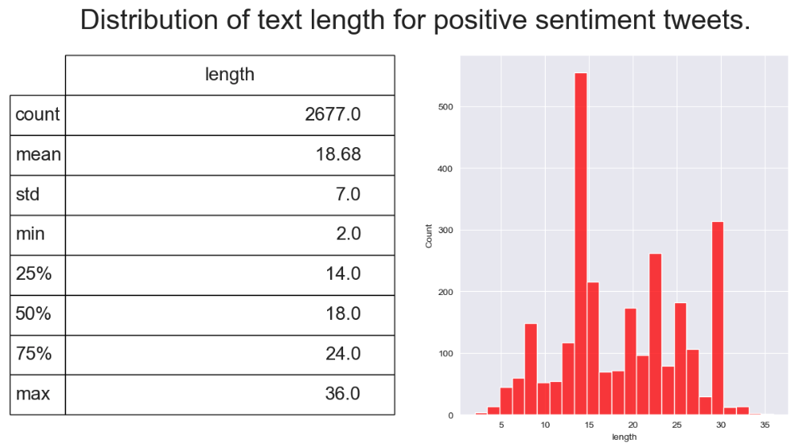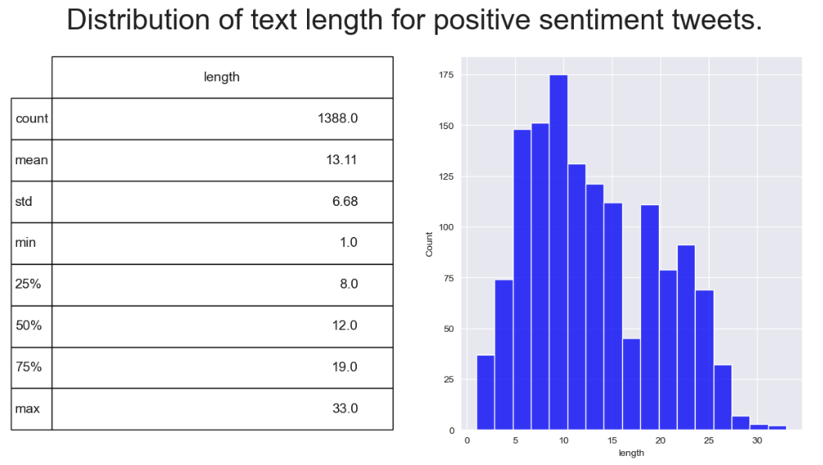

A

B

C

Figure 4.13: Distributions of positive, negative and neutral tweet word lengths and descriptive statistics for each sentiment using VADER sentiment.

A

B

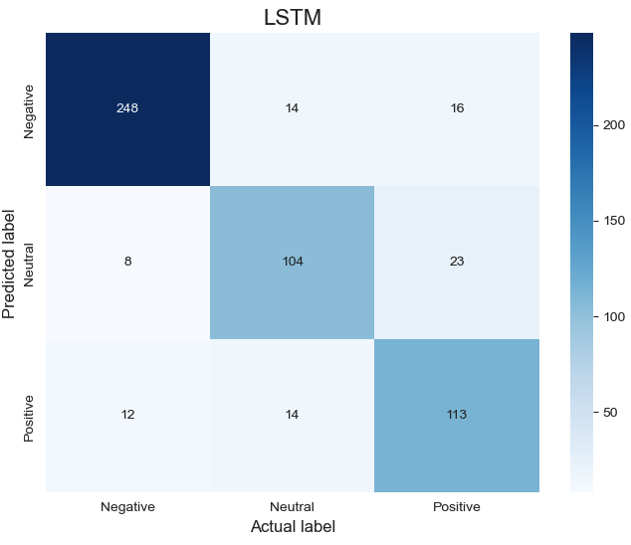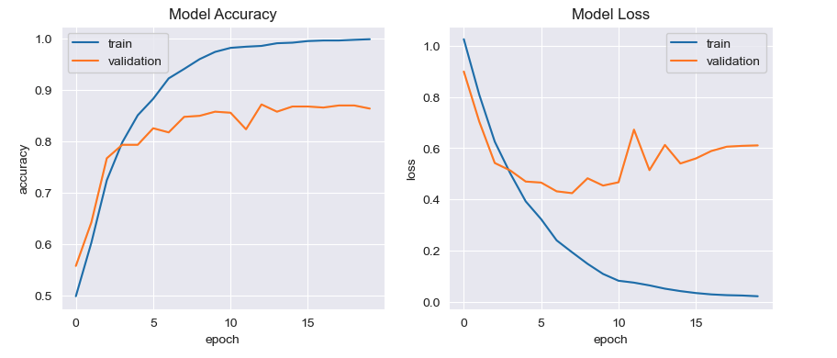

Figure 4.14: Confusion Matrix for correctly predicted sentiment using LSTM and Model accuracy/loss curves for training and validation for VADER sentiment.



Table 4.1: Summary table of accuracy, precision, recall and F1-score for tweet sentiment classification models using TextBlob and VADER.

**4.2 Comparative analysis of primary research with covid 19 tweet sentiment**

To assess the current sentiment around vaccines and gather other relevant information to correlate with sentiment, a Vaccine Awareness Survey was constructed in the manner described in Section 2.10 of the methodology section. The survey recorded 47 response all from people living in Ireland. The sampling method was non-probability, and types were convenience given the relevant populations were close to hand. The entire population was effected by the Covid-19 pandemic thus getting a reflective sample was achievable, however with just under 50 responses only directive insights could be made. To deal with ethical considerations of using a survey around a potentially sensitive topic, the survey was anonymous and no information which could compromise the participants identity was collected. Multiple choice questions were used to streamline answers to the survey for purposes of accurate data collection which could be furtherly analysed to generate qualitative and quantitative insight about the sample set. The participants were given the opportunity not to answer certain questions if they did not feel comfortable asking them with a ‘rather not say’ for more potentially sensitive questions. The participants were notified at the beginning of the survey that the data would be included in a Masters thesis.

The main aim of the survey was to use primary research to collect peoples sentiment in Ireland to compare against the sentiment calculated from the world using the newly generated twitter dataset in results Section 4.1. As shown in Figure 4.15, the sentiment from the sample set is largely ‘Very positive’ or ‘positive’ followed by ‘neutral’ and ‘negative’. Figure 4.16 shows combined ‘Very positive’ and ‘positive’ responses to make the data directly comparable to the twitter sentiment calculated with TextBlob and VADER. Figure 4.16 shows that 76.59 % of people who responded to the survey have a positive sentiment towards Covid-19 vaccines, with 19.14% of responses being neutral and 4.25% being negative. So it can be concluded that the sentiment from this sample of the Irish population is majority positive.

Figure 4.17 shows a comparison of the sentiment calculated with TextBlob and VADER calculated from the tweet dataset compared against the sentiment gathered from the Vaccine Awareness Survey. Panel A of Figure 4.17 shows that the majority sentiment calculated with TextBlob is neutral, followed by positive, then negative. Panel B shows the majority sentiment calculated with VADER from the tweet dataset is negative, followed by positive, then neutral. Both of these majority sentiments are in contrast to the majority sentiments are in contrast to the sentiment collected from the Vaccine Awareness Survey, which is an interesting finding.



Table 4.2: Comparison of percentage of positive, neutral and negative sentiments from TextBlob/VADER tweet sentiment classification and Vaccine Awareness Survey responses.

As mentioned in RO2 a sub aim of the Vaccine Awareness Survey was to collect relevant information which could be correlated with the sentiment data gathered. This includes understanding the distribution of sentiment amongst different age groups, the difference in sentiment and vaccine hesitancy from different employment backgrounds. The hypothesis here is that people from science/health backgrounds given an increased knowledge on the topic of vaccines would have different vaccine sentiment and hesitancy than those not working in these areas. Firstly, it was observed that the largest groups of respondents were in the age brackets of 23-34 and 35-50, with the distribution of sentiment being similar, mainly positive. A smaller number of respondents were in the age 50-65 group with mainly positive sentiment and neutral. The survey only had one respondent in the age bracket of 18-24 which was neutral, but this is only a single response and not enough to gain insight.

Next testing the hypothesis that employment background contributes to vaccine sentiment and hesitancy, the survey data was grouped into people working in health/science and non-health/science areas. Both groups had a majority positive sentiment towards vaccines, 100% for health/science workers and 70.9% for non-science/health workers. This does give some indication that there is a difference in vaccine sentiment between the two employment sub-groups, given that 29.1% of people were neutral or negative in sentiment towards vaccines in the non-science/health worker group. To further this distinction, looking at peoples hesitancy towards vaccines, none were hesitant in the science/health worker group, while 36.7% were hesitant in the non-science/health worker group. These are interesting insights, but would need to be expanded by performing the survey on the wider population to gain accurate insights. Taken together there is a difference in sentiment between the tweet dataset representing the current world sentiment around Covid-19 vaccines and the Vaccine Awareness Survey Sentiment which focuses on Ireland.

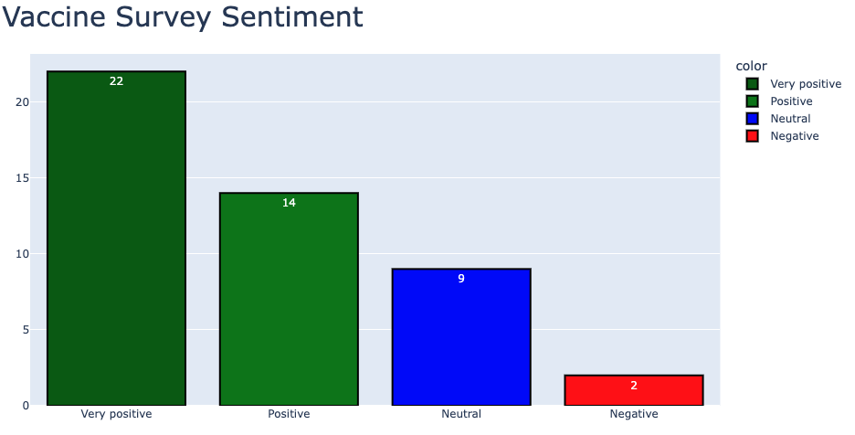

Figure 4.15: Distribution of Very positive, positive, neutral and negative tweets from Vaccine awareness survey.

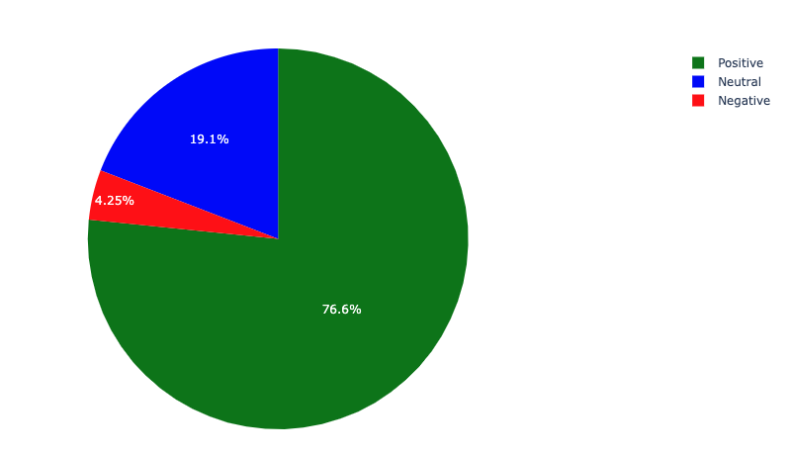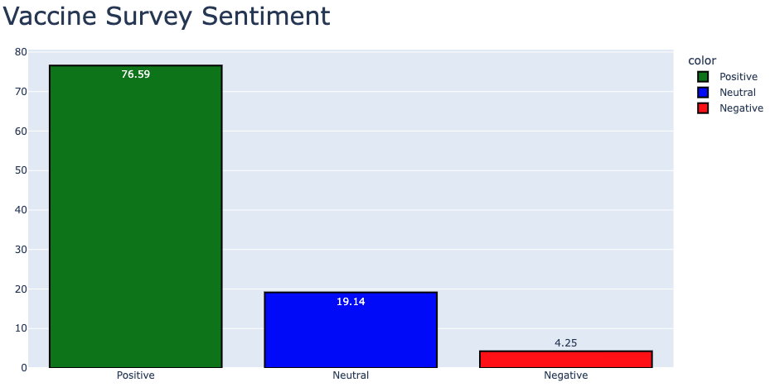

Figure 4.16: Percentages of Vaccine survey sentiment with combined very positive and positive sentiments shown alongside neutral and negative sentiments. To make the survey sentiment data directly comparable to the sentiment mined from the tweet dataset the very positive and positive response was combined.



A

B

C



Figure 4.17: Comparative analysis of vaccine sentiment from tweet dataset with TextBlob/VADER and Vaccine Awareness Survey. (A) Shows tweet sentiment calculated using TextBlob. (B) Shows tweet sentiment calculated using VADER. (C) Shows vaccine sentiment gathered from primary research using Vaccine Awareness Survey.

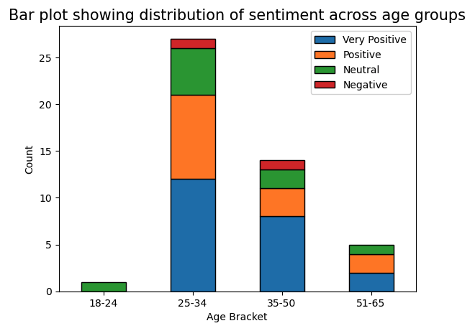

Figure 4.18: Comparison of vaccine hesitancy for peoples working in Health/Science areas and non-health/science areas.

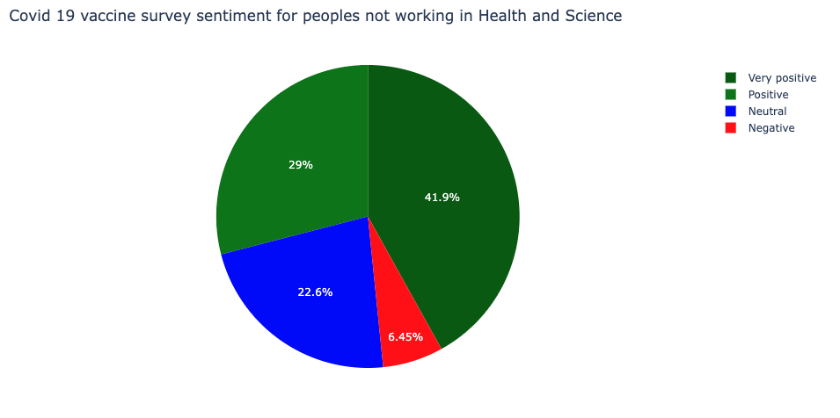

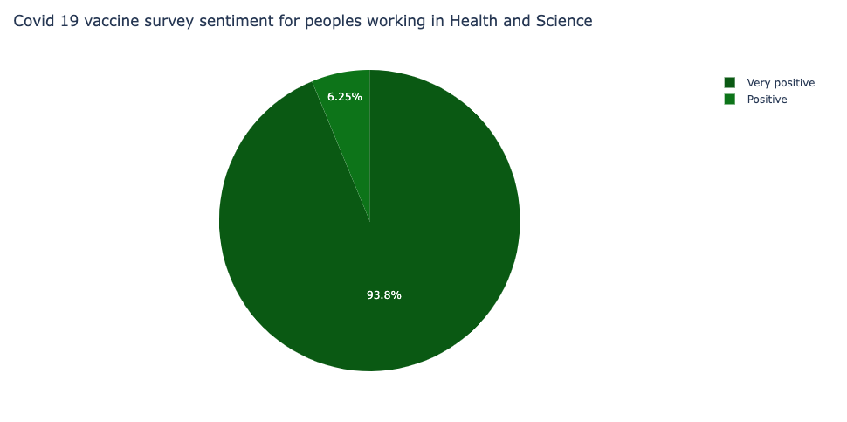

Figure 4.19: Comparison of vaccine sentiment for peoples working in Health/Science areas and non-health/science areas.

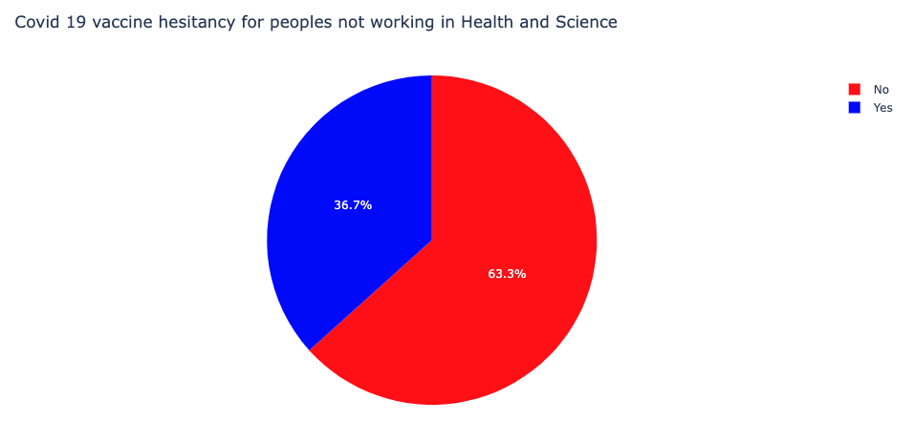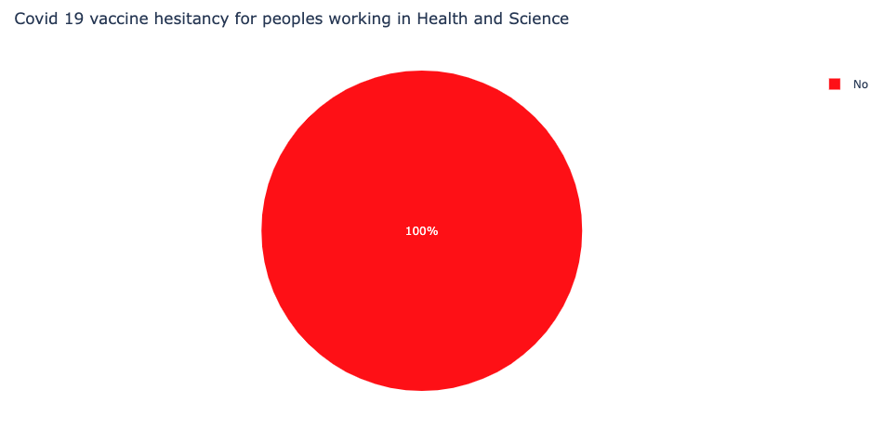

Figure 4.20: Comparison of vaccine hesitancy for peoples working in Health/Science areas and non-health/science areas. The question of whether people felt hesitant about taking a Covid-19 vaccine was posed in the survey. This figure shows whether people in health/ science or not health and science were hesitant or not.

**4.3 Application of forecasting approaches to covid 19 vaccination levels in Ireland**

To address RO3 of this research project, several forecasting approaches were explored for their ability to accurately predict vaccination levels in Ireland. As indicated in the Section 3, many different forecasting approaches have been applied to Covid-19 metrics, showing high accuracies and great promise. The data acquired for this part of the project was taken from data.gov in csv format and detailed the percent of partial and fully vaccinated people of the Irish population in Ireland with the corresponding datetime, among other non-important variables. The models were applied to the fully vaccinated percentage but it can be hypothesized that successful application to fully vaccinated percentage could be applied to partially vaccinated percentage. The initial EDA included exploring and visualising the dataset removing null values and duplicated values of which it contained none. The data of interest, fully vaccinated percentage or FullyPercent as denoted in the accompanying notebook was visualised using matplotlib scatter plot function as seen in Figure 4.21. Given this was a retrospective study and the aim was to apply and obtain the most suitable forecasting models to predict fully vaccinated percentage, the data was truncated by filtering the data from January 2021 to September 2021 before the plateau seen in Figure 4.21(A). This was done for two reasons: 1) To apply different forecasting models to the truncated data and compare against the actual values which are known to be true, 2) The plateau has little variance and would likely not add much value to any model applied in terms of trend, likely leading to poor accuracy or invalid predictions. Figure 4.21(B) shows the a scatter plot of fully vaccinated percentage after truncation.

Given that LSTMs have shown great promise in the prediction in forecasting time series data, the first model that was implemented was an LSTM RNN. The truncated dataset used to train the model was 251 rows in length containing a column with the variable of interest, Fully Vaccinated Percentage (FullyPercent). The dataset was filtered to isolate the FullyPercent column. Eighty percent of the data was used to train the model which equated to 201 rows of data. The data was scaled using min max scaler to reduce large variances and set the percentage value which ranged from 0.000625% to 72.96%, to values between 0 and 1 to increase the likelihood of an accurate model. The timestep chosen was 10 as a starting point for the model and the training data was reshaped to a 3 dimensional dataframe to allow its use in the LSTM which only takes data in tensor format. The LSTM model architecture consisting of an input layer with 20 nodes with return sequences = True. Then a dropout layer of 0.2 to correct for error and allow their removal, then another 20 node LSTM layer with return sequences = False, followed by another 0.2 dropout layer. A dense layer with 10 nodes to fully connect the model and 1 final dense layer with 1 node for output. The loss function chosen was ‘mean_squared_error’ common for linear time series loss with ‘adam’ as the optimizer. A batch size of 5 was chosen and 20 epochs. It was chosen to predict 50 days going forward given this would allow enough time to implement any necessary measures to increase vaccination levels or infrastructure in a hypothetical scenario. The valid predictions versus the actual values can be seen in Figure 4.22. The valid and actual data can be seen visually to closely follow one another. This is quantified with an R squared of 0.90 and RMSE of 1.91, MAPE of 2.5. Attempt were made to enhance the accuracy of this model by adding a CONV1D layer using an sgd optimizer but this lead to a model with variable and poor accuracy. The batch size was experimented with going from 5, 10 and 20 but 5 exhibited the best accuracy.

To compare whether there was any benefit of using the more advanced LSTM approach to a simple RNN, a simple RNN model was generated. As accuracy is not a good measure of RNNs such as LSTM it was dispensed with. The SimpleRNN contained a input layer with 100 nodes and an activation of relu, a dense layer with 20 nodes with a relu activation, and a final dense output layer with 1 node. Again ‘mean_squared_error’ was chosen as the loss function with the optimizer as ‘adam’, batch size = 5 and 20 epochs. Interestingly, the simple RNN showed an increase in R squared compared to the LSTM, 0.92 with an RMSE = 1.67 and MAPE = 2.52. Thus the simple RNN was shown to have a greater accuracy to the LSTM.

Given ARIMA has been applied extensively to Covid-19 metrics as evidenced from the literature review, and compared against models such as LSTM, it was chosen to apply manual and auto ARIMA to the data to see if the models would have superior accuracy. Firstly, a manual ARIMA approach was used, with this approach the values of p, d and q were determined using the partial/auto correlations and statistical tests such as the ad fuller test to test the stationarity of the data. The autocorrelation plot shows significant correlation between lags, with the most significant lag being the first, therefore it was chosen to use 1 for the value of p. Next, the data was differenced using the ‘.diff’ function in python, with 2nd order differencing showing the greatest stationarity, with this confirmed using the adfuller test on the second order differenced data (P-value = 2.475 x 10-15) which indicates stationarity. By using partial correlation plots on the 2nd order differenced data we can also see that the first lag is the most significant affirming p as 1. The value of q was estimated by looking at the autocorrelation plot of the second order differenced data which indicates that a value of 2 would be sufficient to predict future values based on the significance of the first two lags as shown in the third panel of Figure 4.25. The results of the valid vs predicted values for the ARIMA (1, 1, 2) model can be seen in Figure 4.26, visually the valid vs predicted values seem to follow each other well for the first 30 days of prediction but then separate for the following 20 days. The model displayed an RMSE = 3.28 and a MAPE of 3.55 indicating a modest accuracy but lower than the LSTM and SimpleRNN.

Finally, auto ARIMA was used to attempt to optimize ARIMA p, d and q parameters. The best model chosen by the autoARIMA method was an ARIMA(3, 2, 1) model. The residuals of this model were examined as seen in Figure 4.24. The valid vs predicted values for the auto-ARIMA can be seen in Figure 4.26 with the 95% confidence interval for the predicted values shaded in. Visually the predicted vs the actual values are quite different and this is reflected in the high RMSE of 13.36 and MAPE of 17.44. Thus taken together the manual ARIMA approach exhibited the best accuracy metrics for prediction, but the most accurate model was the SimpleRNN followed by the LSTM.

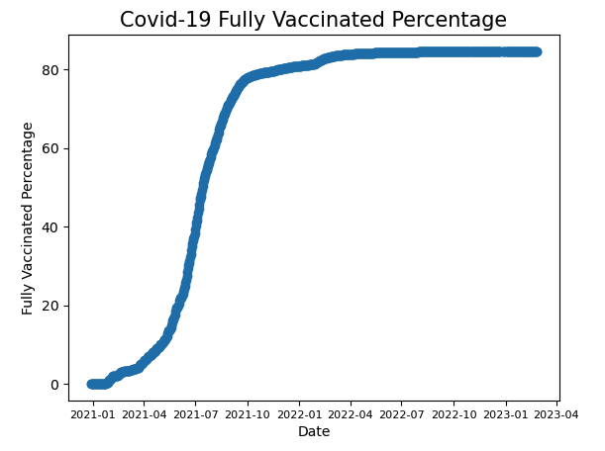

A

B

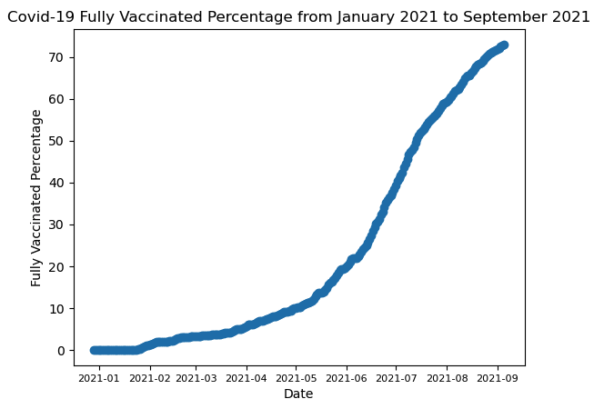

Figure 4.21: Covid-19 fully vaccinated percentage from data.gov dataset. Vaccination data spans from 2020 to 2023. (A) Shows full dataset (B) Shows dataset after truncation.

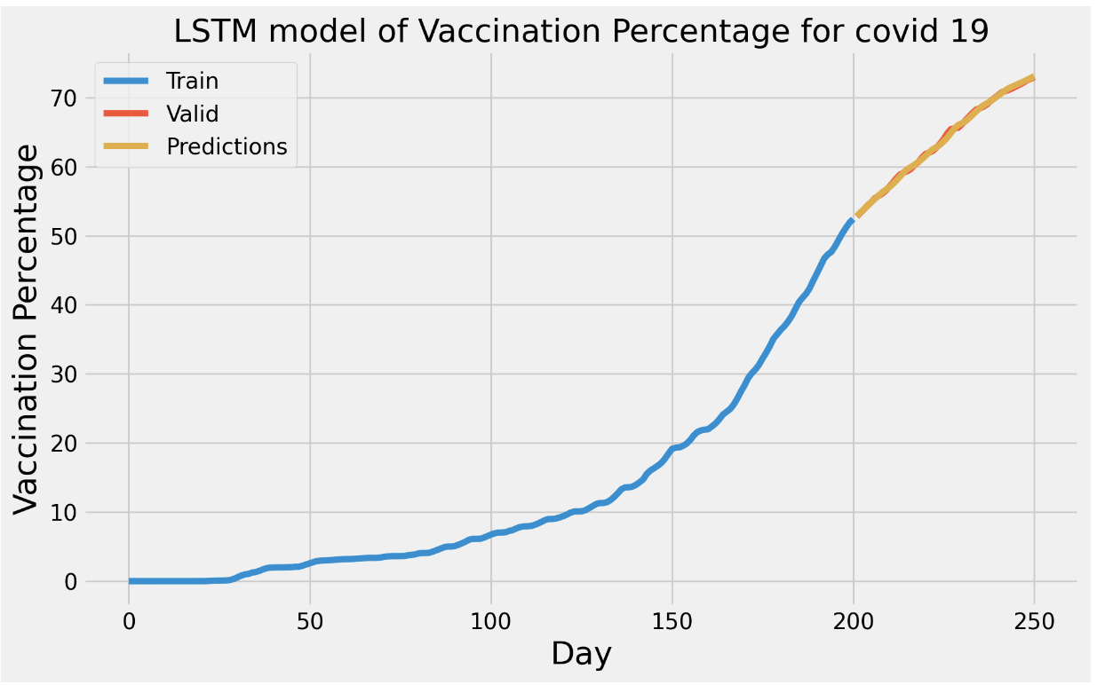

Figure 4.22: Valid vs predicted values for LSTM model.

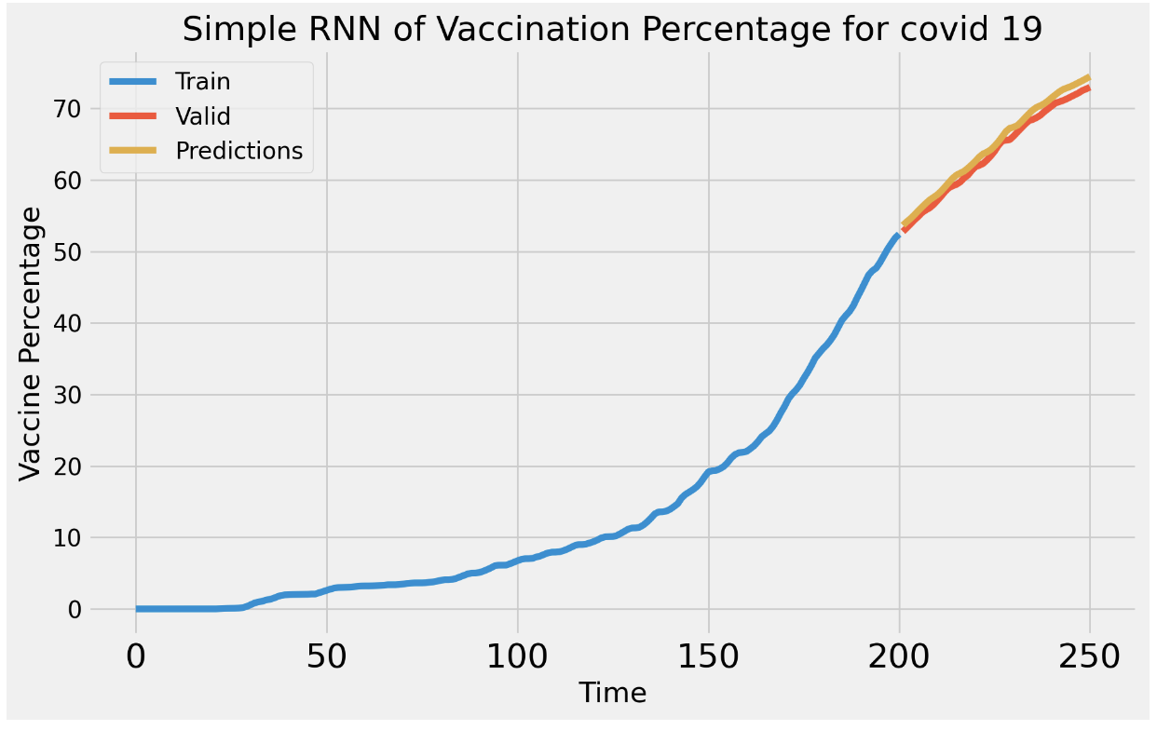

Figure 4.23: Valid vs Predicted values for Simple RNN.

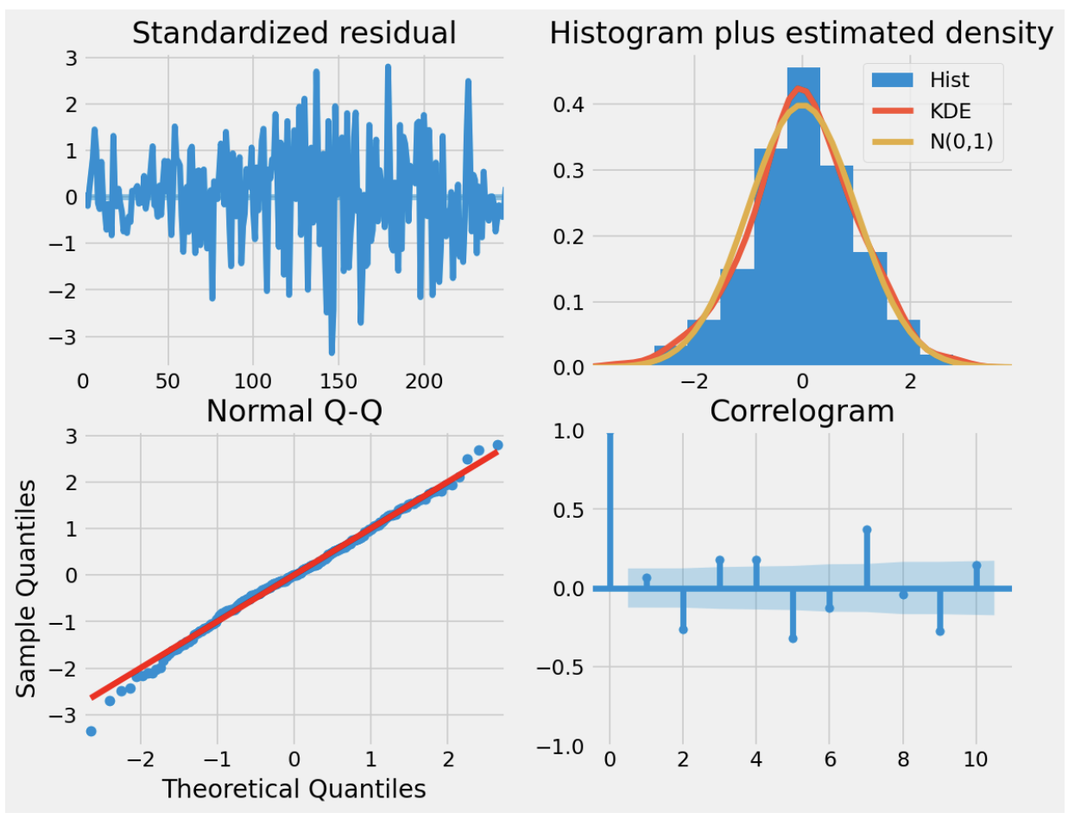

Figure 4.24: Statistical analysis of residuals for ARIMA model.

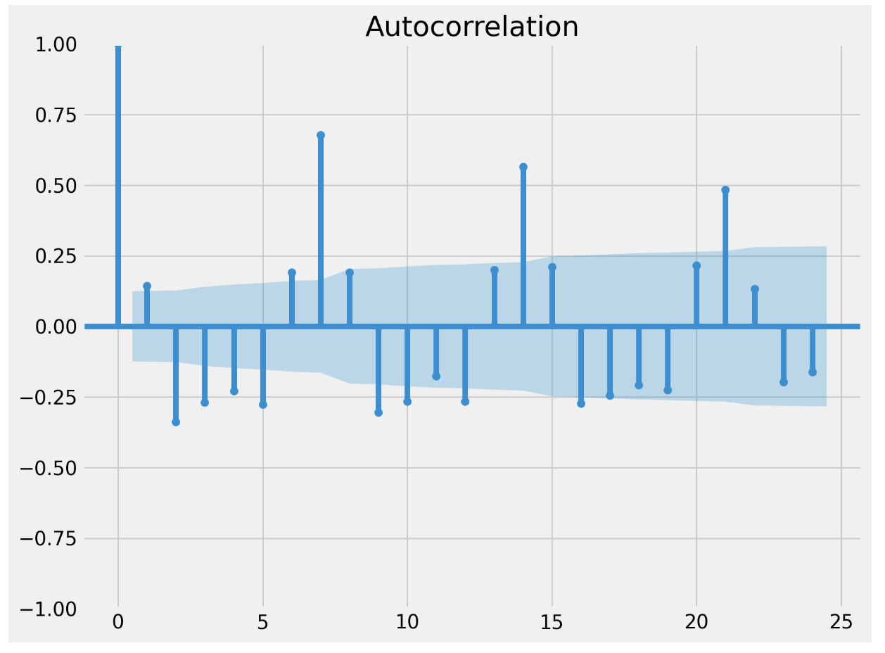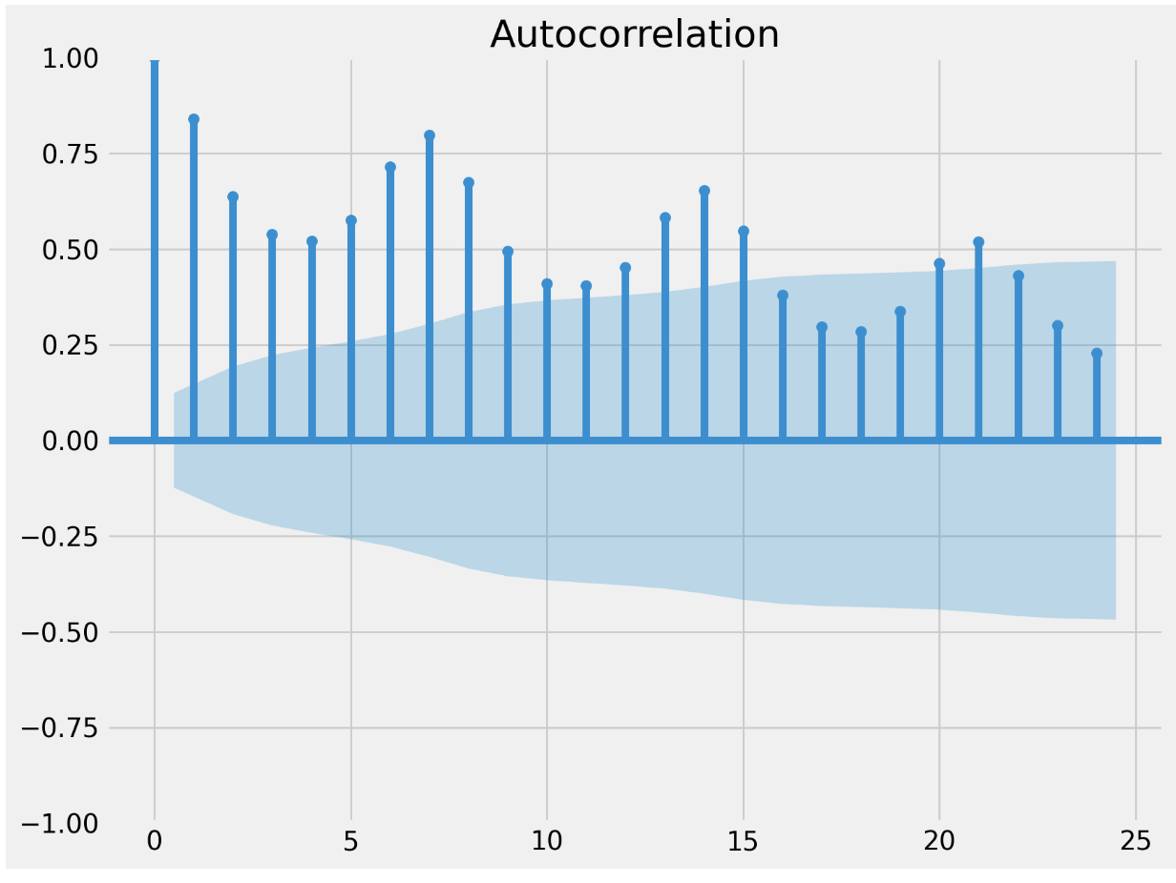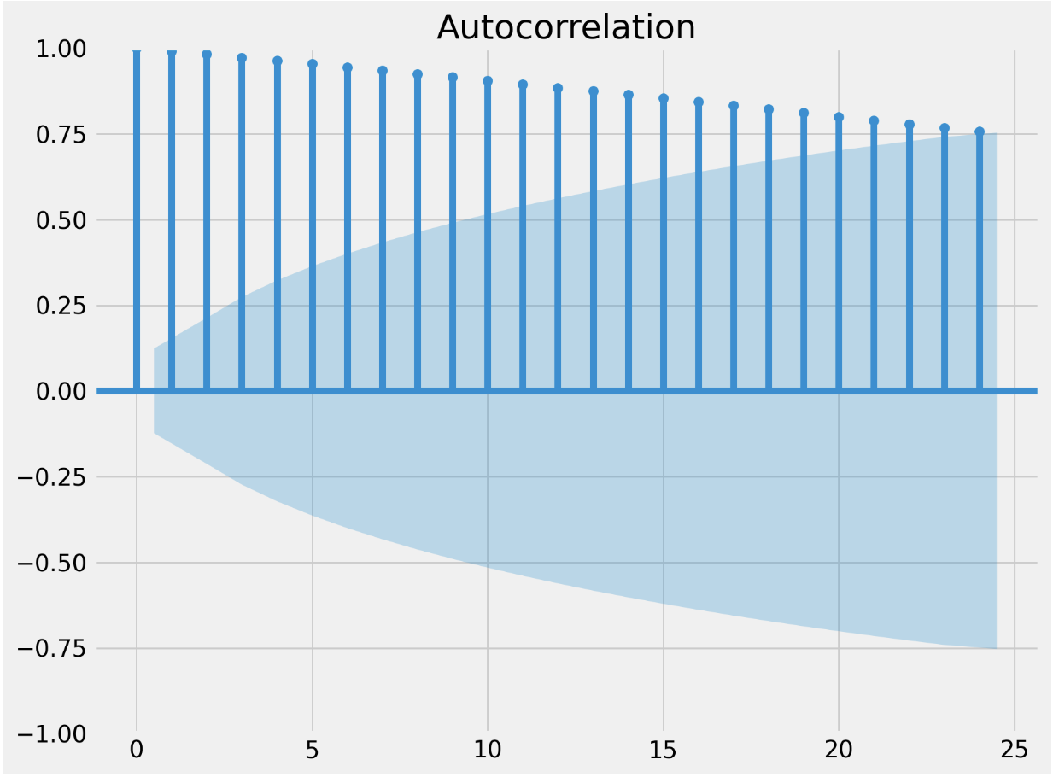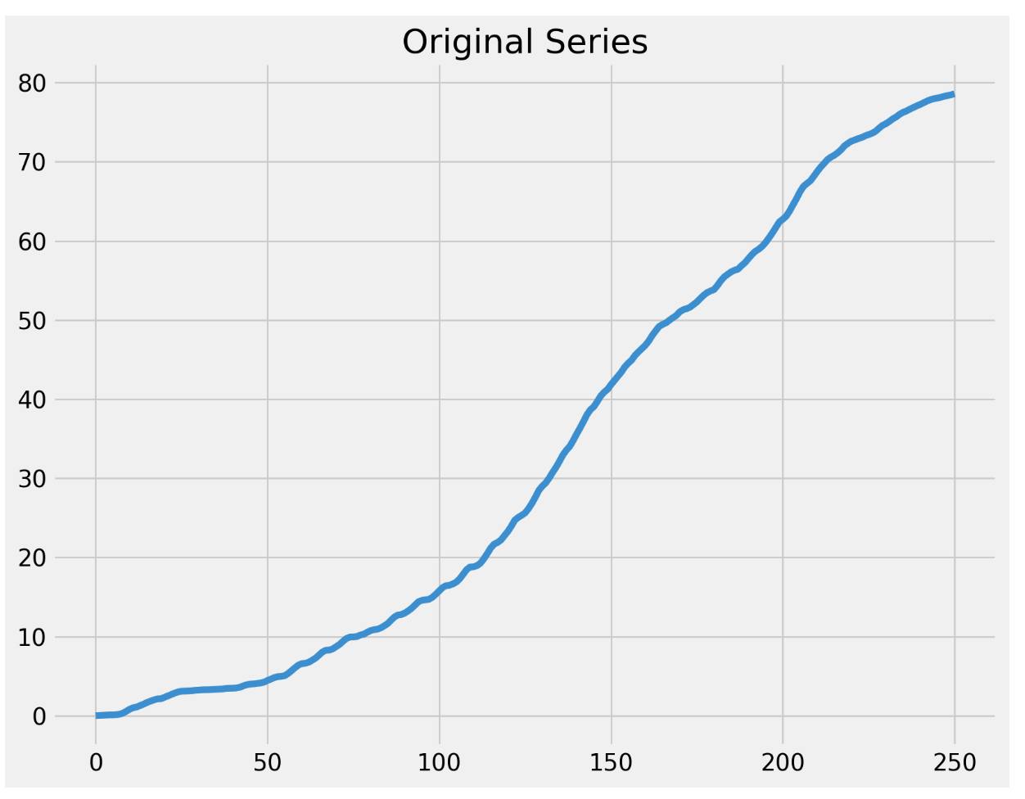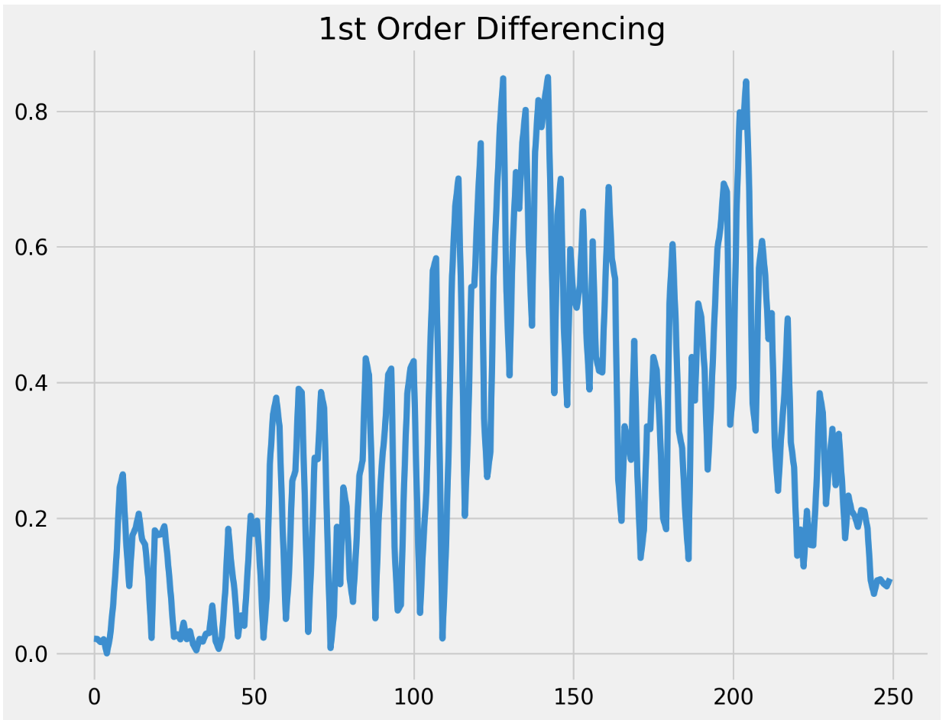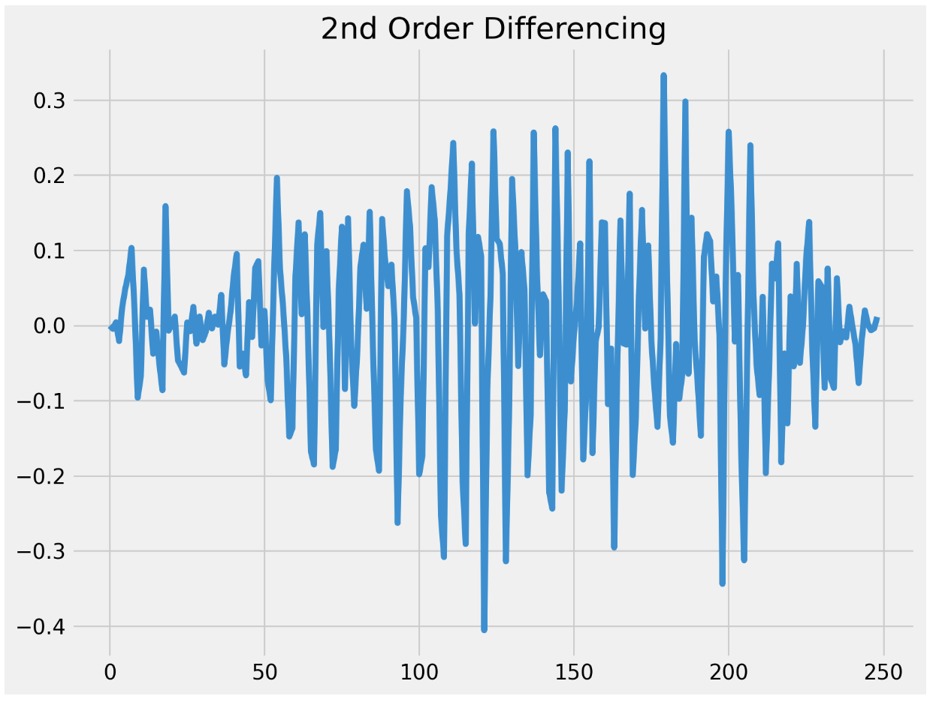

Figure 4.25: Effects of differencing on vaccination data and autocorrelation of differenced time series data.

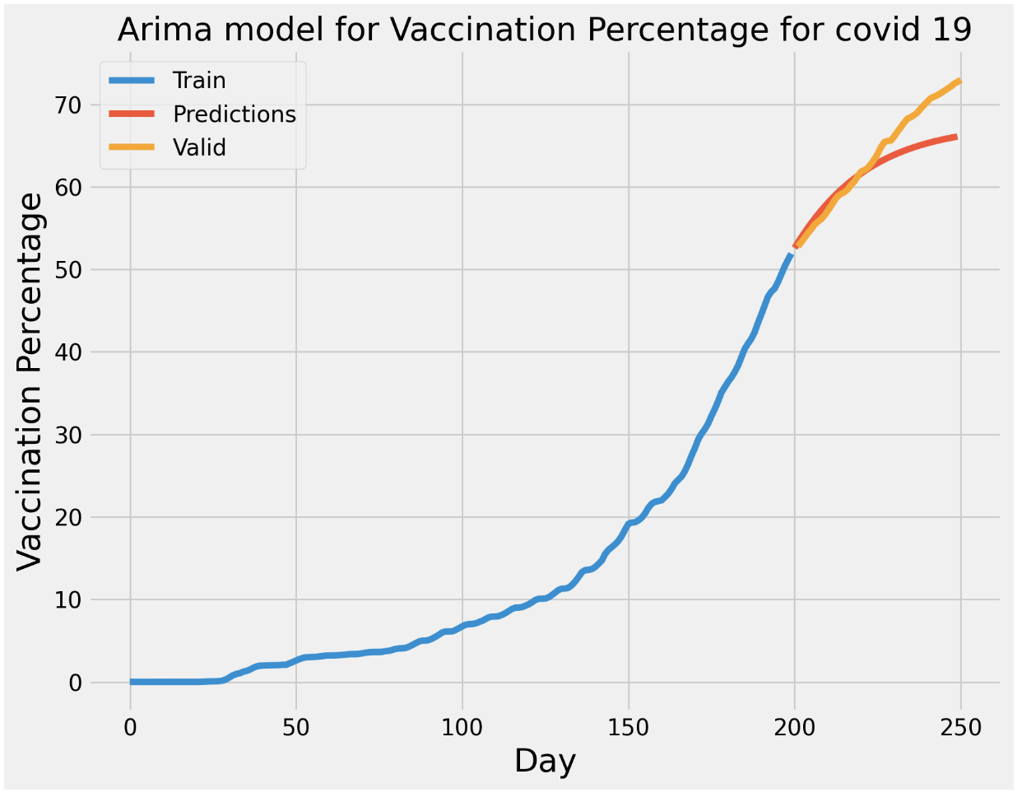

Figure 4.26: Valid vs predicated values for manual ARIMA(1, 1, 2) model.

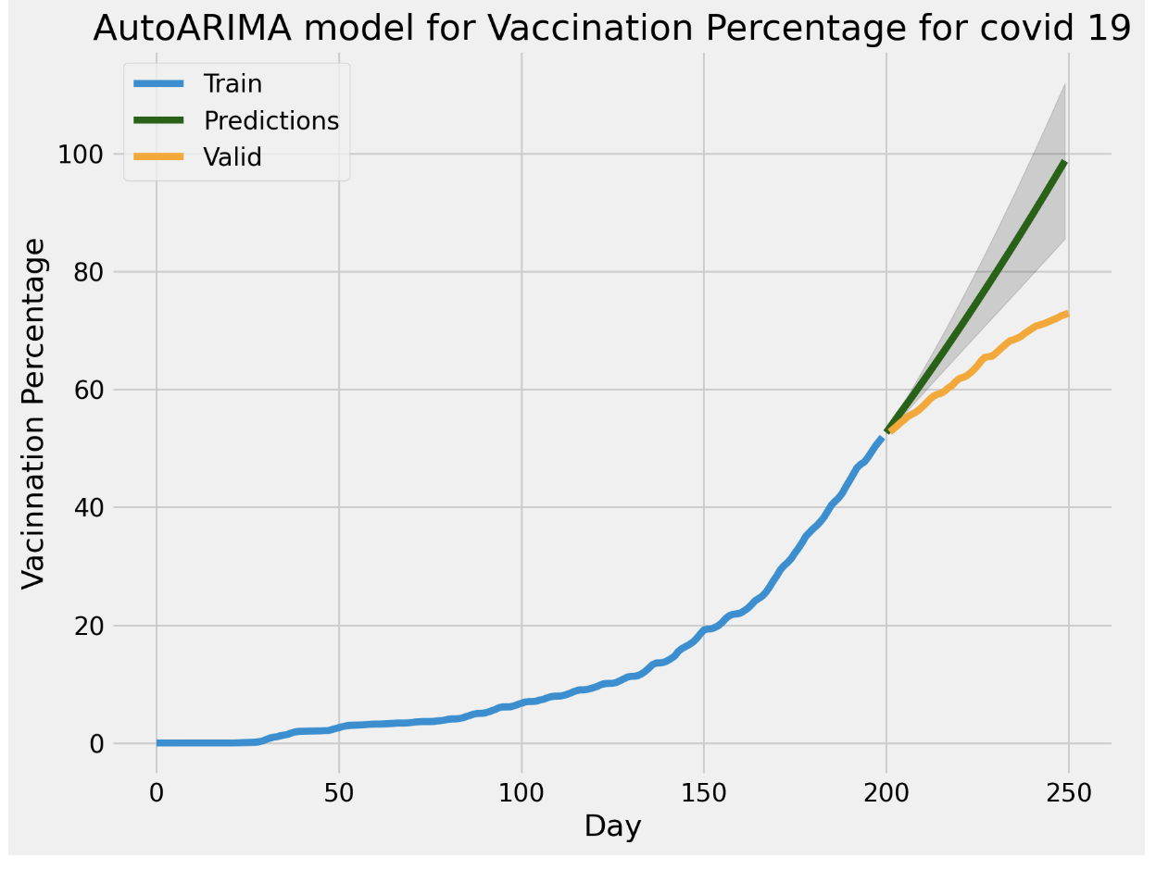

Figure 4.27: Valid vs predicated values for auto-ARIMA (3, 2, 1) model.

**5. Discussion (2000 words)**

The aims of this project as set out by the research objectives 1 to 3 were to apply data analytical approaches such as natural language processing, primary research and forecasting approaches to compare and contrast valuable tools for prediction in Covid-19, with focus on Ireland. The first section evaluated several models for sentiment classification to address RO1, while the second section addressed RO2 using a survey as a primary research technique, to gather sentiment data from Ireland to compare against world sentiment for a newly generated twitter dataset in Section 1. Finally, several forecasting approaches with particular emphasis on time series analysis were used to predict vaccination levels in Ireland in line with RO3.

In results Section 1, the highest performing model was shown to be a combination of TextBlob or VADER for sentiment classification, with TF-IDF for vectorization and ExtraTrees Classifier (ETC), with an accuracy of 0.91. The ExtraTrees model has been shown in studies such as the one presented by Rustam et al. to have high accuracy compared to other models for sentiment classification tasks. Just over 45% of the tweets were given a negative polarity with VADER as the classifier leading to a largely negative training dataset, with a similar bias for neutral sentiment in the TextBlob dataset. It is unclear why there is such a difference in sentiment classification using TextBlob and VADER. It is known that VADER is better at classifying social media data than TextBlob, but given that the ETC model performed similarly in both, leads to the same conclusion, that the ETC model has the highest accuracy for this data. Given ETC models are ensemble techniques like random forest, it is interesting to see the ETC models outperform random forest. A likely reason for this is that instead of using bagging, which takes part of the dataset to build the individual decision trees in random forest, ETC uses the whole dataset, and given the dataset is unbalanced in favour of neutral in the case of TextBlob, and negative in the case of VADER, using the whole data set may lead to the ETC models enhanced accuracy, given individual trees in the random forest model could be more biased towards majority sentiment as only part of the dataset is used. It is likely that an increase in the dataset size form approximately 6*000 tweets* to perhaps a million would see a greater balancing of sentiment in the dataset, or least provide such a high volume of training data that the models accuracy would increase.

The least accurate model for the TextBlob and VADER sentiment datasets was KNN Classifier which is most likely due to the imbalanced nature of both datasets. Interestingly, LSTM had a far greater accuracy using the TextBlob sentiment dataset with an accuracy of 0.9 vs an accuracy of 0.84. Similarly, the XGBoost Classifier was slightly more accurate with the TB sentiment classification dataset than the VD dataset (0.9 > 0.87, respectively). It is likely, that the gradient boosting from the XGBoost Classifier enables weak learner incorporation into the model which again incorporates sentiment classes with a lower representation in the dataset, leading to higher accuracy vs other ensemble methods such as decision tree. Taken together the results from this section of the project indicate that ETC and XGB classifiers generate high accuracy models with imbalanced datasets, likely due to algorithm design. Overall looking at every model evaluated, the TB dataset presented with higher accuracies vs the VD dataset.

What Section 1 also provided was an understanding of the current sentiment on social media towards Covid-19 vaccination. Given that the TB dataset was largely neutral, followed by positive, then negative, and the VD dataset was largely negative, followed by positive, then neutral, it is difficult to make a clear distinction on the current overriding sentiment form the newly generated tweet dataset. Although not the primary concern of Section 1, an understanding of the current sentiment on Covid-19 vaccines has not yet been published in 2023. The new twitter dataset was generated from a 7 day period in August 2023 and thus is reflective on the current dispersion of sentiment around the topic of Covid-19 vaccines. Taking into consideration both sentiment classification sets, the sentiment is mixed, with certainly the least represented sentiment class being positive. The primary research survey carried out as part of RO2 collected real world data and opinion on the current sentiment towards Covid-19 vaccines. This could be hypothesized as a more reliable and definite source of the current sentiment on Covid-19 vaccines in Ireland, as it does not rely on NLP and disparity between the sentiment classification techniques such as TextBlob and VADER. The survey highlighted that 76% of participants felt positive towards vaccines, while 19.1% felt neutral, and 4.25% felt negative. These results are in stark contrast to the twitter dataset, and give some insight to the current sentiment in Ireland towards Covid-19 vaccines. However, the survey only consisted of 47 participants, of a population over 5 million, thus the sample size is likely too small to make any conclusions at this point. It was shown that certain responses such as employment background could be used to pick out differences in feelings of vaccine sentiment and hesitancy, two important areas of consideration during the Covid-19 pandemic. Perhaps this survey if expanded could be used to generated a standalone predictive model for prediction vaccine sentiment and hesitancy by training on a larger dataset. MailChimp offers a ready made platform for online survey deployment and enables the extraction of data in csv format, making the data easily importable to python enviroments where models such as the ones applied in Section 1 could be trained for sentiment classification based on the responses provided.

**6. Conclusions and future work(600 words)**

**Bibliography**

*A Comprehensive Overview of Sentiment Analysis* (no date). Available at: https://www.analyticsvidhya.com/blog/2022/04/a-comprehensive-overview-of-sentiment-analysis/ (Accessed: 17 May 2023).

*A Sentiment Analysis Approach to Predicting Stock Returns | by Tom Yuz | Medium* (no date). Available at: https://medium.com/@tomyuz/a-sentiment-analysis-approach-to-predicting-stock-returns-d5ca8b75a42 (Accessed: 12 August 2023).

Abonazel, M. R. and Darwish, N. M. (2022) ‘Forecasting confirmed and recovered COVID-19 cases and deaths in Egypt after the genetic mutation of the virus: ARIMA Box-Jenkins approach’, *Commun. Math. Biol. Neurosci.*, 2022(0), p. Article ID 17. doi: 10.28919/CMBN/6888.

Abotaleb, M. *et al.* (2021) ‘Modeling Covid-19 Infection Cases and Vaccine in 5 Countries Highly Vaccinations’, *Turk. J. Math. Comput. Sci*, 13(2), pp. 403–417. doi: 10.47000/tjmcs.905508.

Abou-Ismail, A. (2020) ‘Compartmental Models of the COVID-19 Pandemic for Physicians and Physician-Scientists’, *Sn Comprehensive Clinical Medicine*, 2(7), p. 852. doi: 10.1007/S42399-020-00330-Z.

Ahmad, W. *et al.* (2022) ‘Enhanced sentiment analysis regarding COVID-19 news from global channels’, *Journal of Computational Social Science*, p. 1. doi: 10.1007/S42001-022-00189-1.

Al-Garadi, M. A., Yang, Y. C. and Sarker, A. (2022) ‘The Role of Natural Language Processing during the COVID-19 Pandemic: Health Applications, Opportunities, and Challenges’, *Healthcare 2022, Vol. 10, Page 2270*, 10(11), p. 2270. doi: 10.3390/HEALTHCARE10112270.

Alabdulrazzaq, H. *et al.* (2021) ‘On the accuracy of ARIMA based prediction of COVID-19 spread’, *Results in Physics*, 27, p. 104509. doi: 10.1016/J.RINP.2021.104509.

*Applications of Natural Language Processing  | Data Science Dojo* (no date). Available at: https://datasciencedojo.com/blog/natural-language-processing-applications/ (Accessed: 28 August 2023).

*ARIMA & SARIMA: Real-World Time Series Forecasting* (no date). Available at: https://neptune.ai/blog/arima-sarima-real-world-time-series-forecasting-guide (Accessed: 30 August 2023).

*Beginner’s Guide to XGBoost for Classification Problems | Towards Data Science* (no date). Available at: https://towardsdatascience.com/beginners-guide-to-xgboost-for-classification-problems-50f75aac5390 (Accessed: 27 August 2023).

Binti, A. A., Nasir, M. and Palanichamy, N. (2022) ‘Sentiment Analysis of Covid-19 Tweets by Supervised Machine Learning Models’, *Online) Journal of System and Management Sciences*, 12(6), pp. 50–69. doi: 10.33168/JSMS.2022.0604.

Braun, S. (2018) ‘LSTM Benchmarks for Deep Learning Frameworks’. Available at: https://arxiv.org/abs/1806.01818v1 (Accessed: 5 April 2023).

Cascini, F. *et al.* (2021) ‘Developing a Data-Driven Approach in Order to Improve the Safety and Quality of Patient Care’, *Frontiers in Public Health*, 9, p. 667819. doi: 10.3389/FPUBH.2021.667819.

Cepeda, K. and Jaiswal, R. (2022) ‘Sentiment Analysis on Covid-19 Vaccinations in Ireland using Support Vector Machine’, *2022 33rd Irish Signals and Systems Conference, ISSC 2022*. doi: 10.1109/ISSC55427.2022.9826215.

Chandra, R., Jain, A. and Chauhan, D. S. (2022) ‘Deep learning via LSTM models for COVID-19 infection forecasting in India’, *PLOS ONE*, 17(1), p. e0262708. doi: 10.1371/JOURNAL.PONE.0262708.

Chauhan, S. *et al.* (2021) ‘An Artificial-Intelligence-Discovered Functional Ingredient, NRT_N0G5IJ, Derived from Pisum sativum, Decreases HbA1c in a Prediabetic Population’, *Nutrients*, 13(5). doi: 10.3390/NU13051635.

Chinnasamy, P. *et al.* (2022) ‘COVID-19 vaccine sentiment analysis using public opinions on Twitter’, *Materials Today. Proceedings*, 64, p. 448. doi: 10.1016/J.MATPR.2022.04.809.

*COVID-19 Forecasting and Mathematical Modeling | CDC* (no date). Available at: https://www.cdc.gov/coronavirus/2019-ncov/science/forecasting/forecasting-math-modeling.html (Accessed: 9 August 2023).

Crawshaw, A. F. *et al.* (2022) ‘Defining the determinants of vaccine uptake and undervaccination in migrant populations in Europe to improve routine and COVID-19 vaccine uptake: a systematic review’, *The Lancet Infectious Diseases*, 22(9), pp. e254–e266. doi: 10.1016/S1473-3099(22)00066-4/ATTACHMENT/6EF3885D-1921-4ED3-B114-7351A20CCC97/MMC1.PDF.

Devlin, J. *et al.* (2018) ‘BERT: Pre-training of Deep Bidirectional Transformers for Language Understanding’, *NAACL HLT 2019 - 2019 Conference of the North American Chapter of the Association for Computational Linguistics: Human Language Technologies - Proceedings of the Conference*, 1, pp. 4171–4186. Available at: https://arxiv.org/abs/1810.04805v2 (Accessed: 28 August 2023).

Fang, X. and Zhan, J. (2015) ‘Sentiment analysis using product review data’, *Journal of Big Data*, 2(1), pp. 1–14. doi: 10.1186/S40537-015-0015-2/FIGURES/9.

*Forecasting Time Series with Multiple Seasonalities using TBATS in Python | by Grzegorz Skorupa | intive Developers | Medium* (no date). Available at: https://medium.com/intive-developers/forecasting-time-series-with-multiple-seasonalities-using-tbats-in-python-398a00ac0e8a (Accessed: 30 August 2023).

Gecili, E., Ziady, A. and Szczesniak, R. D. (2021) ‘Forecasting COVID-19 confirmed cases, deaths and recoveries: Revisiting established time series modeling through novel applications for the USA and Italy’, *PloS one*, 16(1). doi: 10.1371/JOURNAL.PONE.0244173.

Geurts, P., Ernst, D. and Wehenkel, L. (2006) ‘Extremely randomized trees’, *Mach Learn (*. doi: 10.1007/s10994-006-6226-1.

Gonçalves, P. *et al.* (2013) ‘Comparing and combining sentiment analysis methods’, *COSN 2013 - Proceedings of the 2013 Conference on Online Social Networks*, pp. 27–37. doi: 10.1145/2512938.2512951.

Hewage, P. *et al.* (2019) ‘Long-Short Term Memory for an Effective Short-Term Weather Forecasting Model Using Surface Weather Data’, in *IFIP Advances in Information and Communication Technology*, pp. 382–390. doi: 10.1007/978-3-030-19823-7_32.

*How to Choose a Forecasting Model | by Gosia Komor | Towards Data Science* (no date). Available at: https://towardsdatascience.com/how-to-choose-a-forecasting-model-fa9c4a2e75b8 (Accessed: 28 August 2023).

Huang, R. and Wang, X. (2023) ‘Impact of COVID-19 on mental health in China: analysis based on sentiment knowledge enhanced pre-training and XGBoost algorithm’, *Frontiers in Public Health*, 11, p. 1170838. doi: 10.3389/FPUBH.2023.1170838/BIBTEX.

Iksan, N. *et al.* (2021) ‘Sentiment Analysis of Public Reaction to COVID19 in Twitter Media using Naïve Bayes Classifier’, *InHeNce 2021 - 2021 IEEE International Conference on Health, Instrumentation and Measurement, and Natural Sciences*. doi: 10.1109/INHENCE52833.2021.9537243.

Ingram, C. *et al.* (2023) ‘Exploring key informants’ perceptions of Covid-19 vaccine hesitancy in a disadvantaged urban community in Ireland: Emergence of a “4Cs” model’, *Vaccine*, 41(2), p. 519. doi: 10.1016/J.VACCINE.2022.11.072.

*Introduction to ARIMA for Time Series Forecasting | by Juan Nathaniel | Towards Data Science* (no date). Available at: https://towardsdatascience.com/introduction-to-arima-for-time-series-forecasting-ee0bc285807a (Accessed: 29 August 2023).

Iwendi, C. *et al.* (2020) ‘COVID-19 patient health prediction using boosted random forest algorithm’, *Frontiers in Public Health*, 8, p. 562169. doi: 10.3389/FPUBH.2020.00357/BIBTEX.

Khurana, D. *et al.* (2023) ‘Natural language processing: state of the art, current trends and challenges’, *Multimedia Tools and Applications*, 82(3), pp. 3713–3744. doi: 10.1007/S11042-022-13428-4/FIGURES/3.

Kırbaş, İ. *et al.* (2020) ‘Comparative analysis and forecasting of COVID-19 cases in various European countries with ARIMA, NARNN and LSTM approaches’, *Chaos, Solitons, and Fractals*, 138, p. 110015. doi: 10.1016/J.CHAOS.2020.110015.

Kolchyna, O. *et al.* (2015) ‘Twitter Sentiment Analysis: Lexicon Method, Machine Learning Method and Their Combination’. Available at: https://arxiv.org/abs/1507.00955v3 (Accessed: 12 August 2023).

Koroteev, M. V. (2021) ‘BERT: A Review of Applications in Natural Language Processing and Understanding’. Available at: https://arxiv.org/abs/2103.11943v1 (Accessed: 10 August 2023).

Lalapura, V. S., Amudha, J. and Satheesh, H. S. (2021) ‘Recurrent Neural Networks for Edge Intelligence’, *ACM Computing Surveys (CSUR)*, 54(4). doi: 10.1145/3448974.

Lee, Y. C. and Wu, W. L. (2023) ‘Key Drivers of COVID-19 Vaccine Hesitancy: A Perspective of Collectivism’, *Healthcare*, 11(2). doi: 10.3390/HEALTHCARE11020176.

*Machine Learning Basics with the K-Nearest Neighbors Algorithm | by Onel Harrison | Towards Data Science* (no date). Available at: https://towardsdatascience.com/machine-learning-basics-with-the-k-nearest-neighbors-algorithm-6a6e71d01761 (Accessed: 27 August 2023).

Mansoor, M. *et al.* (2020) ‘Global Sentiment Analysis Of COVID-19 Tweets Over Time’. Available at: https://arxiv.org/abs/2010.14234v2 (Accessed: 21 August 2023).

Melton, C. A. *et al.* (2022) ‘Fine-tuned Sentiment Analysis of COVID-19 Vaccine–Related Social Media Data: Comparative Study’, *Journal of Medical Internet Research*, 24(10). doi: 10.2196/40408.

*Most Popular Distance Metrics Used in KNN and When to Use Them - KDnuggets* (no date). Available at: https://www.kdnuggets.com/2020/11/most-popular-distance-metrics-knn.html (Accessed: 27 August 2023).

Müller, A. C. and Guido, S. (2016) *Introduction to Machine Learning with Python: A Guide for Data Scientists*. O’Reilly Media, Incorporated. Available at: https://books.google.ie/books?id=qjUVogEACAAJ.

Müller, M., Salathé, M. and Kummervold, P. E. (2023) ‘COVID-Twitter-BERT: A natural language processing model to analyse COVID-19 content on Twitter’, *Frontiers in Artificial Intelligence*, 6, p. 1023281. doi: 10.3389/FRAI.2023.1023281/BIBTEX.

*Naives Bayes Classifiers for Machine Learning | by Madison Schott | Capital One Tech | Medium* (no date). Available at: https://medium.com/capital-one-tech/naives-bayes-classifiers-for-machine-learning-2e548bfbd4a1 (Accessed: 26 August 2023).

Qiu, B. and Fan, W. (2021) ‘Machine learning based short-term travel time prediction: Numerical results and comparative analyses’, *Sustainability (Switzerland)*, 13(13). doi: 10.3390/su13137454.

Qorib, M. *et al.* (2023) ‘Covid-19 vaccine hesitancy: Text mining, sentiment analysis and machine learning on COVID-19 vaccination Twitter dataset’, *Expert Systems with Applications*, 212, p. 118715. doi: 10.1016/J.ESWA.2022.118715.

*Random Forest Algorithm for Absolute Beginners in Data Science* (no date). Available at: https://www.analyticsvidhya.com/blog/2021/10/an-introduction-to-random-forest-algorithm-for-beginners/ (Accessed: 26 August 2023).

*Random Forest Algorithm for Machine Learning | by Madison Schott | Capital One Tech | Medium* (no date). Available at: https://medium.com/capital-one-tech/random-forest-algorithm-for-machine-learning-c4b2c8cc9feb (Accessed: 26 August 2023).

*Regular Expressions — An excellent tool for text analysis or NLP | by Niwratti Kasture | Analytics Vidhya | Medium* (no date). Available at: https://medium.com/analytics-vidhya/regular-expressions-an-excellent-tool-for-text-analysis-or-nlp-d1fa7d666cb9 (Accessed: 17 May 2023).

Ressan, M. B. and Hassan, R. F. (2022) ‘Naïve-Bayes family for sentiment analysis during COVID-19 pandemic and classification tweets’, *Indonesian Journal of Electrical Engineering and Computer Science*, 28(1), pp. 375–383. doi: 10.11591/IJEECS.V28.I1.PP375-383.

Rguibi, M. A. *et al.* (2022) ‘Forecasting Covid-19 Transmission with ARIMA and LSTM Techniques in Morocco’, *SN Computer Science 2022 3:2*, 3(2), pp. 1–14. doi: 10.1007/S42979-022-01019-X.

Rodríguez-Ibánez, M. *et al.* (2023) ‘A review on sentiment analysis from social media platforms’, *Expert Systems with Applications*, 223, p. 119862. doi: 10.1016/J.ESWA.2023.119862.

Rustam, F. *et al.* (2021) ‘A performance comparison of supervised machine learning models for Covid-19 tweets sentiment analysis’, *PLoS ONE*, 16(2). doi: 10.1371/JOURNAL.PONE.0245909.

Sarkar, D. (2016) ‘Text Analytics with Python’, *Text Analytics with Python*. doi: 10.1007/978-1-4842-2388-8.

Savage, N. (2021) ‘Tapping into the drug discovery potential of AI’, *Biopharma Dealmakers*. doi: 10.1038/D43747-021-00045-7.

Schröer, C., Kruse, F. and Gómez, J. M. (2021) ‘A systematic literature review on applying CRISP-DM process model’, *Procedia Computer Science*, 181, pp. 526–534. doi: 10.1016/J.PROCS.2021.01.199.

Shahid, F., Zameer, A. and Muneeb, M. (2020) ‘Predictions for COVID-19 with deep learning models of LSTM, GRU and Bi-LSTM’, *Chaos, Solitons, and Fractals*, 140, p. 110212. doi: 10.1016/J.CHAOS.2020.110212.

Shastri, S. *et al.* (2020) ‘Time series forecasting of Covid-19 using deep learning models: India-USA comparative case study’, *Chaos, solitons, and fractals*, 140. doi: 10.1016/J.CHAOS.2020.110227.

Shinde, G. R. *et al.* (2020a) ‘Forecasting Models for Coronavirus Disease (COVID-19): A Survey of the State-of-the-Art’, *SN computer science*, 1(4). doi: 10.1007/S42979-020-00209-9.

Shinde, G. R. *et al.* (2020b) ‘Forecasting Models for Coronavirus Disease (COVID-19): A Survey of the State-of-the-Art’, *SN computer science*, 1(4). doi: 10.1007/S42979-020-00209-9.

Somyanonthanakul, R. *et al.* (2022) ‘Forecasting COVID-19 cases using time series modeling and association rule mining’, *BMC Medical Research Methodology*, 22(1), pp. 1–18. doi: 10.1186/S12874-022-01755-X/TABLES/8.

Srivastava, A. and Anto, S. (2022) ‘Weather Prediction Using LSTM Neural Networks’, in *2022 IEEE 7th International conference for Convergence in Technology, I2CT 2022*. Institute of Electrical and Electronics Engineers Inc. doi: 10.1109/I2CT54291.2022.9824268.

*Stemming and lemmatization* (no date). Available at: https://nlp.stanford.edu/IR-book/html/htmledition/stemming-and-lemmatization-1.html (Accessed: 28 August 2023).

*Support Vector Machine — Introduction to Machine Learning Algorithms | by Rohith Gandhi | Towards Data Science* (no date). Available at: https://towardsdatascience.com/support-vector-machine-introduction-to-machine-learning-algorithms-934a444fca47 (Accessed: 27 August 2023).

Syeda, H. B. *et al.* (2021) ‘Role of Machine Learning Techniques to Tackle the COVID-19 Crisis: Systematic Review’, *JMIR Medical Informatics*, 9(1). doi: 10.2196/23811.

*Text Classification with BERT. In this tutorial, we will use BERT to… | by Khang Pham | Medium* (no date). Available at: https://medium.com/@khang.pham.exxact/text-classification-with-bert-7afaacc5e49b (Accessed: 12 August 2023).

*TextBlob | Making Natural Language Processing easy with TextBlob* (no date). Available at: https://www.analyticsvidhya.com/blog/2021/10/making-natural-language-processing-easy-with-textblob/ (Accessed: 17 May 2023).

*TextBlob vs. VADER for Sentiment Analysis Using Python | by Amy @GrabNGoInfo | Towards AI* (no date). Available at: https://pub.towardsai.net/textblob-vs-vader-for-sentiment-analysis-using-python-76883d40f9ae (Accessed: 15 August 2023).

*The Vanishing/Exploding Gradient Problem in Deep Neural Networks | by Kurtis Pykes | Towards Data Science* (no date). Available at: https://towardsdatascience.com/the-vanishing-exploding-gradient-problem-in-deep-neural-networks-191358470c11 (Accessed: 5 April 2023).

*Time series forecasting- SARIMA vs Auto ARIMA models | by Omega Markos | Analytics Vidhya | Medium* (no date). Available at: https://medium.com/analytics-vidhya/time-series-forecasting-sarima-vs-auto-arima-models-f95e76d71d8f (Accessed: 30 August 2023).

*Tokenization in NLP: Types, Challenges, Examples, Tools* (no date). Available at: https://neptune.ai/blog/tokenization-in-nlp (Accessed: 28 August 2023).

*Understanding LSTM Networks -- colah’s blog* (no date). Available at: http://colah.github.io/posts/2015-08-Understanding-LSTMs/ (Accessed: 5 April 2023).

Vaithilingam, S. *et al.* (2023) ‘COVID-19 vaccine hesitancy and its drivers: An empirical study of the vaccine hesitant group in Malaysia’, *PLOS ONE*, 18(3), p. e0282520. doi: 10.1371/JOURNAL.PONE.0282520.

Wang, M. and Hu, F. (2021) ‘The Application of NLTK Library for Python Natural Language Processing in Corpus Research’, *Theory and Practice in Language Studies*, 11(9), pp. 1041–1049. doi: 10.17507/TPLS.1109.09.

*What? When? How?: ExtraTrees Classifier | by Karun Thankachan | Towards Data Science* (no date). Available at: https://towardsdatascience.com/what-when-how-extratrees-classifier-c939f905851c (Accessed: 27 August 2023).

*What are Recurrent Neural Networks? | IBM* (no date). Available at: https://www.ibm.com/topics/recurrent-neural-networks (Accessed: 5 April 2023).

*XGBoost: Everything You Need to Know* (no date). Available at: https://neptune.ai/blog/xgboost-everything-you-need-to-know (Accessed: 27 August 2023).

Xu, L., Magar, R. and Barati Farimani, A. (2022) ‘Forecasting COVID-19 new cases using deep learning methods’, *Computers in Biology and Medicine*, 144, p. 105342. doi: 10.1016/J.COMPBIOMED.2022.105342.

Yamak, P. T., Yujian, L. and Gadosey, P. K. (2019) ‘A comparison between ARIMA, LSTM, and GRU for time series forecasting’, *ACM International Conference Proceeding Series*, pp. 49–55. doi: 10.1145/3377713.3377722.

Zain, Z. M. and Alturki, N. M. (2021) ‘COVID-19 Pandemic Forecasting Using CNN-LSTM: A Hybrid Approach’, *Journal of Control Science and Engineering*, 2021. doi: 10.1155/2021/8785636.